SIMITS ZSUZSA 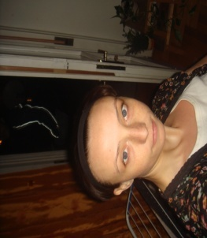
38.POZSONYI STREET, BUDAPEST 1137, HUNGARY
PHONE:0036 30 9516 994 • E-MAIL :LEPTIR@FREEMAIL.HU (SMALL LETTERS)
DATE OF BIRTH 1983 04 24, OSIJEK, CROATIA
GENDER FEMALE
EDUCATION:
2002- 2005:
KING SIGISMUND'S COLLEGE, BUDAPEST, HUNGARY, ECONOMIST- HUMAN RECOURCes
2005-2006:
OKJ-Estate- proffessional training
WORK EXPERIENCE:
2002-2010:
INTERPRETER AND ASSISTANT (English-Hun-Croatian,Serbian)
FOR HIMEX&BAUSMART CO.,
and
FOR THE CROATIAN CHAMBER OF ECONOMY,ZAGREB

OTHER SKILLS:
UPPER LEVEL OF CROATIAN AND ENGLISH LANGUAGE, croatian: native
DRIVING LICENSE
HIGH EXPERIENCE IN WORKING WITH PEOPLE (IMPROVISATION& MOVEMENT THERAPY)

