Curriculum Vitae

Zeus Priadika Priyono
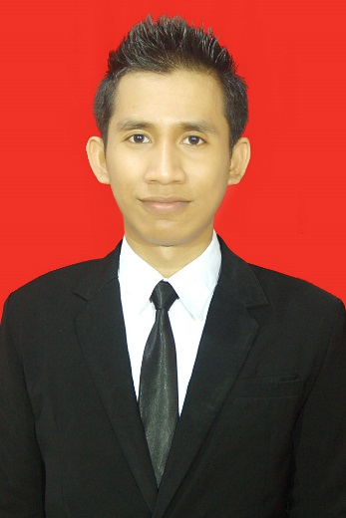
Kecipir Timur Number 6, Ngaliyan, 50185, Semarang City, Indonesia
zeus.priadika@gmail.com
(+62)89650400762
EDUCATIONS, COURSES, AND TRAINING

Desember 3th, 6th, 2020 PT. Inter Strada Solutrindo
Certified awareness training by PJK3 company. (certificate can be seen in folder by scanning the QR code, the file was named as AK3U and Awareness)
- K3 Pertambangan
- K3 Migas Offshore
- K3 Migas Onshore
- ISO 50001:2018
- ISO 9001:2015
- ISO 14001:2015
- ISO 45001:2018
- ISO 22001:2018
November 30th , 2020 PT. Inter Strada Solutrindo
Certified awareness training by PJK3 company. (certificate can be seen in folder by scanning the QR code, the file was named as AK3U and Awareness)
- HSE Plan
- HIRADC
- CSMS
- ISO 33000:2018
Nov 16th – 28th, 2020 Manpower Ministry of Republik Indonesia
Certified as candidate of General OHS expert by Ministry of Manpower. Training was held by PJK3 company (PT. Inter Strada Solutrindo). (certificate can be seen in folder by scanning the QR code, the file was named as AK3U and Awareness)

January 11th, 2020 Balai Penerapan Teknologi Konstruksi, Direktorat Jendral Bina Konstruksi – Kementerian Pekerjaan Umum dan Perumahan Rakyat

Training as Ahli Muda K3 Konstruksi

2017 – 2019 Energy University, by Schneider Electric
List of courses (certificate can be seen in folder by scanning the QR code):
- European Codes and Standard : New Horizons for Buildings
- Go Green with Leadership in Energy and Environment Design
- Energy Procurement III: Balanced Hedging Strategies
- Energy Procurement II: Introduction to Hedging in Deregulated Markets
- Energy Procurement I: Options in Regulated and Deregulated Markets
- Financing and Performance Contracting for Energy Efficiency Project
- Commissioning for Energy Efficiency
- HVAC Sytem III : Air-and-Water and All-Water Sytems
- HVAC System II : All-Air Systems and Temperature Control
- HVAC System I : Introduction to HVAC Systems
- Building Control II : Control Sensors
- Building Control I : An Introduction to Building Controls
- Waste Heat Recovery
- Strategic Energy Planning
- Energy Efficiency with Building Automation Systems II
- Energy Efficiency with Building Automation Systems I
- Building Control VII : Interactive Illustration of PID Responses
- Building Control VI : When to Use Each Responses
- Building Control V : Proportional and PID Responses
- Building Control IV : Two Position and Floating Responses
- Building Control III : Introduction to Control Loop
- Combustion Processes
- Boiler Types and Opportunities for Energy Efficiency
- Power Factor and Harmonics
- Fuel II : Energy Value Analysis – US Customary Units
- Fuel I : Energy Sources and Trends
- Electrical Concepts
- Active Energy Efficiency Using Speed Control
- Energy Rate Structures II : Understanding and Reducing Your Bill
- Energy Rate Structures I : Concepts and Unit Pricing
- Measurement and Verification Including IPMPV
- Measuring and Bencmarking Energy Performance
- Energy Efficiency Fundamentals
- Energy Audits

2014 – 2019 Diponegoro University
Majoring in Environmental Engineering.
Undergraduate Thesis Title : Mapping of Diponegoro University Carbon Footprint at Energy Sector – Electricity
Internship Report Title : Water Quality Analysis and Monitoring of Semarang City (at Dinas Lingkungan Hidup Kota Semarang.)
IPK/GPA = 3.18

2011 – 2014 SMAN 3 Semarang (Senior High School)

ORGANIZATION AND WORKING EXPERIENCE

July 26th – Sept 8th, 2021 TMLEnergy, PT
As Safetyman/HSE Officer at Industri Jamu dan Farmasi Sido Muncul, PT on 2 MWp Rooftop Solar Power Plant Project. The fuction of monitor OHS aspects in a project is the main responsibility.
June 12th – July 26th, 2021 TMLEnergy, PT
As Safetyman/HSE Officer at Apparel One Indonesia, PT on 489,6 kWp Rooftop Solar Power Plant Project. The fuction of monitor OHS aspects in a project is the main responsibility.
June 20th, 2020 – August 1st wk ezDI, Inc.
As Freelance Transcriptionist/Transcriber in Indonesian and Malay Project. My job was to transcribe audio in Bahasa Indonesia and Malay into text. This project is used to develop AI (Artificial Intellegence) in ezDI product such as ezMediscribes. I’m join this project since June 20, 2020 until end of project in first week in August 2020.

Feb 2018 – Feb 2019 Diponegoro University
As Project Member Assistant in UI GreenMetric 2018. My job was to gathering energy consumtion data and calculate emmision. The results are carbon footprint and energy conservation and efficiency recommendations.

September 15th, 2018 World Cleanup Day
As Central Java Coreteam. We planned to held World Cleanup Day activities from World Cleanup Day Academy and the main activity of the day of World Cleanup Day 2017 in Central Java.

September 22th – 25th, 2017 Kementrian Koordinator Bidang Kemaritiman
As Volunteer in Ekspedisi Nusantara Jaya 2017. We got task from the committee – as a representation of Kementerian Koordinator Bidang Kemaritiman, to develop economy, spread environmental and education knowledge, and increase our attention on the glorious of Indonesian archipelago.

July 25th – August 19th, 2017 Dinas Lingkungan Hidup Kota Semarang
As Intern in Environmental Laboratory. My job was to monitor, , measure, analyze water&wastewater and calculate the water quality around Semarang City based on Goverment Regulation.

2015 – 2016 Diponegoro University Environmental Study Group
As Public Relations Staff in Public Relations Division. We as a team, connect the intern of the organisation with outsider and vice versa. For instance, community service and endorse for spreading knowledge in environment, economy, and social policy and best practices.

2013 – 2014 OSIS (Student Association of SMAN 3 Semarang)
OSIS is a school organization that has responsibility in controlling various school activities and taking care of students' extracurricular activities. I became a Leader of Web Design Subsection.

SKILLS AND INTEREST

Native speaker of Indonesian, frequent user of Words, Power Point, and Excel. Enjoy listening radio, singing, reading. Interested in job that related with health, environment, logistic, energy, mining, and hospitality.
Hard Skills
- Bahasa Indonesia | Advance | - HIRADC | Intermediate
- English | Intermediate | - SMK3 | Intermediate
- Ms Office | Intermediate | - Job Hazard/Safety Analysis | Intermediate
- Ms Project | Intermediate | - SMK3 Audit | Intermediate
- EPAnet | Intermediate | - High Conservation Value (HCV) Assessment | Intermediate
- ArcGIS | Intermediate | - Social Environmental Impact Assessment | Intermediate
- AutoCAD | Intermediate | - Microbiolgy Analysis | Intermediate
- Energy Audit | Walk-Through – Standard | - Water&wastewater treatment, Plant and Design | Intermediate
- ISO 9001:2015 | Intermediate | - Air Pollution Control | Intermediate
- ISO 14001:2015 | Intermediate | - Indor Air Pollution Control | Intermediate
- ISO 45001:2018 | Intermediate | - AMDAL/RKL-RPL/PROPER | Intermediate
- ISO 50001:2018 | Intermediate | - Green House Gases (GHGs) Assessment | Advance
- ISO Management System Audit | Intermediate | - Solid Waste & Hazardous Waste Management | Intermediate

Soft Skills
Decision Making | Intermediate
Leadership | Intermediate
Time Management | Intermediate
Communication | Intermediate
Personal Development | Intermediate
Team Working | Intermediate

Semarang, Sept 2nd, 2021

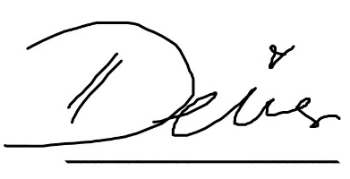
Zeus Priadika Priyono

