CURRICULUM VITAE
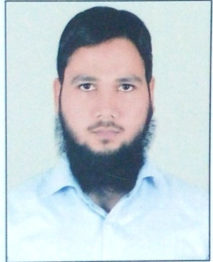
ZAFEER AHMAD
H. NO, 248 4TH FLOOR Gaffar Manzil Extn Jamia Nagar OKHLA, NEW DELHI 25
EMAIL ID: zafeerhmdkn7@gmail.com
CONTACT NO: +91 9911341848 / +91 9648585757
CAREER OBJECTIVE
To continuously enhance my knowledge, skills and experience by getting involved in challenging work environment and utilize them for personal and organizational growth to the best of my ability.
WORKING EXPERIENCE
- Total two years’ experience in professional work. Details are as follows:
- Working currently with Vaidam Healt India, Gurugram, Haryana 122001 (medical travel assistant company) as a Case Manager in patient relations team since Jan 2019.
- From May 2017 to March 2018, worked as Arabic / Urdu to English and vice versa translator at Delhi-based Company named Press Monitor, Business news and information service, Pvt Ltd, dealing with translating and summarizing the TV debates and talk shows.
- Working at the same company as freelance translator from March 2018 onwards.
ACADEMIC QULIFICATION
EXAM / DEGREE | BOARD / UNIVERSITY | YEAR OF PASSING | PERCENTEAGE
M.A. ARABIC | UNIVERSITY OF DELHI | 2018 | 81.43
B.A (H) ARABIC | JAMIA MILLIA ISLAMIA | 2016 | 75.80
CEP (COMMUNI ENGLISH PROG) | JAMIA MILLIA ISLAMIA | 2013 | A grade
FADHILAT = 12TH | DARUL ULOOM DEOBAND | 2011 | 75.70
ALIM = 12TH | UP MADRSA EDUCATION BOARD | 2012 | 62.55
MUNSHI = 10TH | UP MADRSA EDUCATION BOARD | 2009 | 63.28
COMPUTER SKILLS
- General: Basics of Computer Hardware & Software.
- Good at using Ms-Office (Ms-Word, Ms-Excel, Ms-Power Point)
- Typing: Arabic & English, 25 & 28 WPM respectively,
JOB SKILLS
- Ability to work in a team.
- Committed to work in project deadlines and schedules.
- Organized and well-structured at work.
EXTRA CURICULAM ACTIVITIES
- Gen. Sec. Subject Association, Department of Arabic JMI in 2015-16
- Awarded Gold Medal by Jamia Millia Islamia as a toper of B.A. (H) Arabic batch 2013-2016.
- Awarded Gold Medal by University of Delhi as a toper of M.A. Arabic batch 2016-2018.
- UGC NET (National Eligibility Test) qualified in July 2018.
PERSONAL DETAILS
Father’s Name : Arshad Husain
Date of birth : 05.01.1990
Nationality : Indian
Marital Status : Single
Languages Known : Arabic, English, Urdu, and Hindi
DECLARATION
I, ZAFEER AHMAD, hereby declare that the information and facts given above are true to the best of my knowledge and belief.

Date:
Place: (Zafeer Ahmad)

