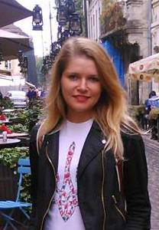
CV
Yuliia Vavryniuk
Lutsk, Ukraine
Phone: +380660221744
E-mail: iuliiababak@gmail.com
Date of Birth: 03 January 1989
Place of Birth: Ukraine
Citizenship: Ukraine
Sex: Female
Marital Status: Married
Education: Lesia Ukrainka Volyn National University, Master’s degree in English philology, teaching English language and literature and French language), September 2006 – June 2011
Work Experience: Building company (salt rooms construction), international business development manager, April 2014 – till now
Lesia Ukrainka Volyn National University, expert of foreign relationship department, September 2011 – November 2011
Language school, teaching English to both children and adults, September 2010 – September 2011
Abroad experience:
Cultural exchange program ‘Au pair’ in The Netherlands, November 2011 – November 2012
‘Au pair’ in Belgium, January 2013 – January 2014
Languages:
Ukrainian – mother tongue
Russian – fluent
English – fluent
French – Pre-Intermediate
Dutch – Basic
German – Basic

