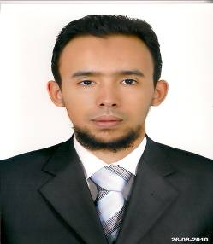
Youness LAADRAOUI
Bloc Laayoune Extension Dakhla NO 77/ Agadir
Morocco/ Agadir city
Mobile : +212635818522
Email: youness.laadraoui@gmail.com
Married
31 years old

Work Experience
2013-2017 : Data analyst in EDI (Exchange Data International) Office in
Agadir. (Morocco)
2012-2016 : Freelance Arabic-English/English-Arabic translator
2012-2016 : Freelance English-French/ French-English translator.
2012-2016 : Freelance French-English translator.
2012-2013 : English teacher in ATTARAJI private school in Agadir.
2011-2012 : English teacher in Uni-tec vocational school at Aitmelool.
2010-2011 : English teacher in Anwal public school (Hired teacher) in Agadir.
2010-2011 : English teacher in MERISE private school in Agadir.
2010-2011 : English teacher in MERISE private school in Agadir.
2010-2011 : Call agent in MO CALL call center.
2009-2010 : Internship certificate in the company GPA of Groupe Kabbage.
2008-2009 : Certificate of the participation in the internship in the training of cupping therapy on the meridians in ERSEN (Casablanca).
2006-2007 : Official certificate of thanks from "the house of charity" During the medical mission team in Taroudant as a translator.

Education and Qualifications:

2009/2010 : Certificate of pursuing the OFFSHORING training the branch
« Opérateur de vente » (Sale operator) in ISTA (Agadir/ Morocco).
2008/2009 : License degree in English language (second-class honors) at Ibno zohr
University in (Agadir/ Morocco).
2007-2008 : Certificate of (DEUG) in English language in the
University of Ibno zohr .
2006-2007 : Certificate of completion of "Fundamentals of teaching English as a foreign language" in American centre.
IT skills:
Operating systems : Windows xp, vista, 7, 8 and 10.
Business software : WORD, EXCEL (well versed).
Languages:
Arabic : Mother tongue.
English : Excellent.
French : good.
Hobbies:
Reading, sport and internet.

