Yazan Zeid Al-karalleh
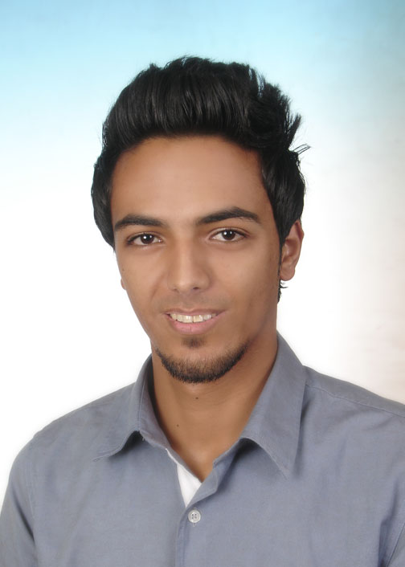

Email : Yazangraffiti@hotmail.com
Phone Number: 0785170446
ID Number: 9911042853
Sex: Male
Date/place of Birth: August 12, 1991 / Zarqa,Jordan
Marital Status: Single
Religion: Islam
Nationality: Jordanian
Address: 16th Street - Zarqa,Jordan
Languages: Engilsh , Arabic

Objective:

- Trying to enhance my knowledge and capabilities by working in a dynamic organization that prides itself in giving substantial responsibility to new talent.

Education :

- Prince mahomet Public High school, Zarqa 2009.
- BA degree in English language and literature (very good grade) 2013.
Department of English literature,Al Albayt University,Mafraq (2010-2013)

Training and Certifications:
- Training of Trainers on Gender-Based Violence (ToT): Focusing on Sexual Abuse.
and Exploitation . (Certificate: To assist each participant to take their next step as a facilitator or trainer).

- passinng The National English Language Test 28/10/2013.

experiences:

- English teacher at "Rossan Academy" Zarqa, Jordan ( January 2012 - April 2012)
Job Role: Education/Training
- (English language Teacher) Teaching English language grammar,writing,speaking and listening skills in homes for elementary, intermediate students for 2 years .
# Recognizing Individual Differences in my Students and Adjust Their Practice Accordingly.
# Being fully aware of health and safety issues and how to deal with classroom emergencies.
- Marketing service in clothes stores 2 years ( Zarqa).

Target Industry:
Community/Social Services/and Nonprofit; Education, Training, and Library; Healthcare, Practitioner and Technician; Human Resources; Safety/Environment; Public Relations; Translation.
Other Skills and Qualifications:
- Good cultural awareness and sensitivity.
- Excellent Proofreading ,adjustment and editing texts in Arabic and English.
- Excellent oral and written communications skills in Arabic and English.
- Net Working.
- Knowledge and experience with a wide variety of computer, applications technologies (Microsoft Word,Access, excel, and PowerPoint) .
- Freelance writer, Graffiti artist, photographer.
- Having driving license.
- Statistical analysis.
- Flexible in working hours and willing to work in remote areas.
- Information management.
- Experience facilitating focus group discussions or workshops.
- Ability to facilitate program and community interactions regardless of
ethnicity, status, gender, origin or affiliation.
- Excellent analytical, problem solving, decision making, and crisis control skills
- A passion for learning new technologies and finding better solutions
- Comfortable with being the ‘go to’ person in a company.
- Thinking laterally to create options and solutions.
- Positive ‘can do’ attitude towards work.
- Ability to create a stimulating teaching environment for students by being motivated, enthusiastic and confident

Community Service/ Activities:
- Creating Street Panting (Words,Caricature) for set decorations and managed transportation of set pieces around Amman,Zarqa,Mafraq,Madba (2008) .
- Take part in Amman Street Artfair 27/9/2011.
- Volunteer for USAID Jordan in panting school walls, Zarqa 8/6/2012.
- Volunteer for Association of care for people with special needs Zarqa, Dhlail 10/4/2013.
- Take part in Baladk (experimental art project) 11/5/2013.

Keywords:
Teacher , Social Worker , Assistant , Education , Logistic , Mobilization Assistant

