YAMILA NOELIA BENÍTEZ
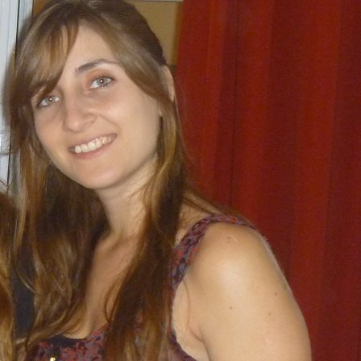
Personal Information
-I.D.: 34.169.624
- Date of Birth: 20th, October 1988.
- Place of Birth: City of La Plata.
- Marital Status: Single.
- Domicile: Diag. 73 nº 2882 Dpto B. La Plata (1900).
- Mobile Phone: (0221) 15 5733222.
- E-mail: yamibenitez@hotmail.com
Educational Background
- HIgh School Degree with Humanities and Social Sciences orientation. Virgen del Pilar Institute; DIEPREGEP 4024. La Plata. 2006.
Undergraduate Degree
- English and Spanish Translator (University of La Plata)
-English Teacher (ongoing) ( University of La Plata)
Further Studies
International Proofreader in Spanish; Fundación Litterae; Buenos Aires, Argentina. 2014- currently.
Work Experience
- Private English lessons. All levels. May 2007 – Currently.
- Nuestra Señora del Carmen School, 115 between 530 y 531. Tolosa, Buenos Aires, Argentina. English Teacher. March, 2010.
- “El sol”School, 508 between 25 y 26, Hernández, Buenos Aires, Argentina. English Teacher. April-November, 2010
-Escuela Nº 8 School, 48 between 9 y 10. La Plata, Buenos Aires Argentina. English Teacher. May- June, 2010.
-Escuela n°34 School , 8 between 56 y 57. English Teacher. La Plata, Buenos Aires, Argentina. June- August, 2010.
-Escuela nº 29 School, 25 between 526 y 527. La Plata, Buenos Aires. English Teacher. May – July 2011.
-Instituto Cassati, School of Medical Care; 5 between 59 y 60; La Plata, Buenos Aires, Argentina, Technical English Classes of Radiology and Nursery; August 2011- currently.
-Student Collaborator of the Introductory Course of English and Spanish Translator. University of La Plata. February-March 2013
- San Cayetano School, 44 between 30 and 31, La Plata, Argentina; English classes for beginners. March 2014.
- Teaching assistant in Literary Translation, a subject for students of the fourth year of the English Translator Course, at University of La Plata; La Plata, Buenos Aires, Argentina, 2014- currently.
- Translator at Digital Humanities Association 2014- currently
-Intern at University of La Plata, Argentina, for the community Docentes en Línea.

Translations (2011- currently)
-Technical Translations (Maths, Finance, Economics, Scientific, Medicine, Accountancy):
-Translation from Spanish into English of a 760-word abstract. Translation based on Harmonic Analysis. University of La Plata. 2011
-Translation from Spanish into English of a Financial Manual for the non-governmental organization Teach-a-Man-To-Fish. 2011.
Translations of Environment documents:
-Translation from English into Spanish of a paper based on an Eco-labelling Program. UNEP . 2011
Literary Translations:
- Translation from Spanish into English for Digital Humanities website (http://aahd.com.ar/)
-Translation from English into Spanish of the article Triumphal Forms by Alastair Fowler.
-Translation of The Happy Prince, by Oscar Wilde into Spanish
-Translation of Borges on Poetry and Translation in Theory and Practice, by
Nataly Tcherepashenets
Proofreading:
-Proofreading and Editing of a Spanish Report into English. UNEP. 2012
-Proofreading and Editing of a Spanish Legal paper into English, 2014
-Website translation based on publicity and Graphic Desing for “DisobeyMedia”. -
2012

Seminars and Workshops
-Undergraduate 50-hour Seminar, “Introducción a la didáctica del Inglés en la escuela pública”. May- November 2010. University of La Plata [UNLP]
- Collaborator Student in Comparative Literature Workshops, from 17th to 20th, August 2011. UNLP
-3-hour Seminar. “Español: seminarios de actualización. Módulo de verbos I”. Colegio de traductores de la Ciudad de Buenos Aires. February 2012.
- 4-hour Undergraduate Seminar. “La Jerga de los Médicos y la jerga de los Pacientes”. Dictado por Fernando Navarro. April 2012
- 4-hour Undergraduate Seminar. “Ejercicios Prácticos de traducción con textos Médicos Británicos: Principales Diferencias con Respecto al Inglés Estadounidense”. Dictado por Fernando Navarro. April 2012
- Collaborator Student in “Primera Jornada Profesional Regional “– Celebration of Translator’s Day. Province of Buenos Aires, La Plata. September 2012.
- Computer Assisted Translations Tools, 30 hours. March-July 2013
-Collaborator Assistant in the 6th Workshop Modern Languages. University of La Plata. La Plata. October/November 2013

Other Languages
Italian, Intermediate Level.
Computer Knowledge
- Windows XP, Microsoft Word, Excel, Access, Power Point and Internet.
CAT TOOLS
Trados Studio SDL, X-bench, Wordfast, Memo Q, Tag Editor, and Memsource.
Subtitle edit

