Resume of Ms Win Pa Pa San
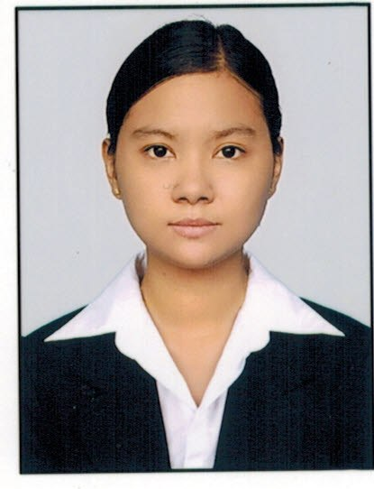

Ms Win Pa Pa San (aka) Crystal Win
English to Burmese/ Burmese to English Translator
Email: winpapasan86@gmail.com
Mobile: 09420107604
Address: No. 114/116, 5th Floor, Corner of 57th Street and Maharbandula Road,
Pazundaung Township, Yangon, Myanmar

“Translation is not just changing one language into a different language; it’s bridging the mind and heart of people speaking different languages around the world.”
Previously worked in different industries in Yangon, Myanmar, I am a freelance translator, specialized in the area of children psychology, education, marketing, art and culture, lifestyle, travel, health, teaching, literature and environmental subject. Moreover, I am good at meeting deadline, teamwork, communicating cross-nationally and contributing information effectively.
I am a member of PEN Myanmar, a branch of PEN International which is a worldwide association with a membership of prominent literary writers and editors. I was selected as a candidate to join the Link the Wor(l)ds International Literature Translation seminar and workshop which was held by PEN Myanmar with the help of Penguin Publishing, the British Council, Select Centre, Writer’s Center Norwich and PEN International. I was selected as a member of 10 candidates – who were chosen among the translators all over the country. Stories which were translated during workshop by the team were published with the Title Link the Wor(l)ds.

Language
- English - Excellent
- Burmese – Native Language or Mother Tongue
- Rakhine Dialet – Native Language or Mother Tongue

Translating Experience

- I have translated medical documents, survey reports about agricultural and ethnic media as a freelance translator.
- I have translated a lot of articles online for Yoyarlay Website and Facebook Page.
- I have translated a lot of articles and written articles in bilingual English and Burmese (a sort of translating) for Yangon Life Website and Facebook Page.
- I have translated movie subtitles for a lot of movie for Movie-5 (Family Entertainment Co. Ltd).
- I have translated short stories from Malay Sketches by Singaporean Author “Alfian Saat” and the book will be published from “Ngar Doe Sar Pay” Publishing House.

Working Experience
- 12th December 2015 to 30th June 2016 - I have worked for Yoyarlay Social Media Website and Fan Page as an Operation Manager, leader of the editorial team handling with writing, translating, content creating and social media marketing. Main duties and responsibilities were setting guideline for the content creating, arranging the advertisement, discussing and consulting with the clients who advertise their product or service on our Social Media.
- 4th June 2014 to 8th October 2015 - I have worked for Consilium Co. Ltd. (Yangon Life Website yangonlife.com.mm) as a senior writer and one of the key content creators. Main duties and responsibilities were content creating, translating, Facebook posting and writing articles and press release of events in both languages – English and Burmese.
- January 2011 to May 2014 - I have worked as a freelance English translator and English teacher. I had studied literature and writing as well as had learnt a lot of experiences in translating and teaching. In 2013, I had set up a preschool named University for Kids as private partnership and developed an English curriculum for the preschool as well as a set of objectives for early child care development.
- April 2008 to November 2010 - I have worked for Family Entertainment Co. Ltd. (5 Movie) as an English translator. I have got a lot of experiences in translating English subtitle of the movies into Myanmar subtitle.
- 2006 to 2008 - I have worked for Bright Star International Centre (BSi Centre) as an English teacher. I have got great exposure to English language by teaching English four skills to the students of Beginner Level and Intermediate Level.

Educational Qualifications

Bachelor of Education (Q), Yangon Institute of Education (2001 – 2005)
Diploma in English, SEAMEO Chat in Yangon (2004 – 2006)
Certificate of Competence in Microsoft Excel in Business Application, KMD (2008)
Certificate of Completion in Link the Wolds, PEN Myanmar (2015)

Membership
A life member of PEN Myanmar

Reference
Daw Thida : President, PEN Myanmar Center
Phone – 095182581, drmathida1966@gmail.com
Daw Phyu Phyu Mar : General Manager and Adviser, Consilium Co. Ltd.
Phone – 095045838, phyuphyumar.july@gmail.com

