CURRICULUM VITAE

Dr. Vishal Vilas Burungale
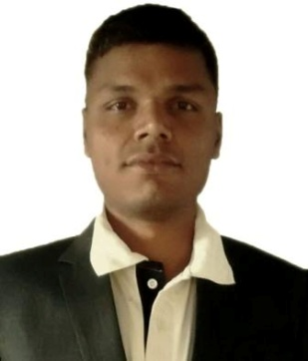

DESIGNATION:

Assistant Professor,

School of Nanoscience and Technology,

Shivaji University,

Kolhapur.

OFFICE ADDRESS:

School of Nanoscience and Technology,

Shivaji University, Vidyanagar,

Kolhapur- 416004.

Phone: 02312609490

Email: vishalburungale@gmail.com

HOME ADDRESS:

At. – Ganeshvadi,

Post- Vaduj

Tal. - Khatav,

Dist.- Satara

Pin – 415506

M.S., India

PERSONAL DETAILS:

Birth Date: 9th May 1990

Nationality: Indian

Marital Status: Single

Sex: Male.

2. Academic Record
Sr. No. | Exam. Passed | Board/  University | Subjects Studied | % of marks  obtained | Class Obtained | Year of Passing
1. | Ph.D. | Shivaji University | Physics | -- | -- | 2017
2. | M. Sc. | Shivaji University | Physics  (Solid State Physics) | 69.66% | Distinction | 2012
3. | B. Sc. | Shivaji University | Physics | 73.16% | Distinction | 2010
4. | H.S.C. | Pune | Physics, Chemistry, Mathematics, Biology | 71% | First Class | 2007
5. | S.S.C. | Mumbai | All | 80.80% | Distinction | 2005

WORK EXPERIENCE:
I have published one non-science fiction Marathi Story and Four poetry collection books on Matrubharati e-book publishing portal, namely
1. Niyati-1
2. Niyati-2
3. Nishabd antarang- 1
4. Nishabd antarang- 2
5. Nishabd antarang- 3
6. Nishabd antarang- 4
One another book will be published on 14 December 2017 namely,
1. Kawadasa
For details of all books please refer link given below,
https://www.matrubharti.com/authors/3662
I hereby declare that all the information given above is correct to the best of my knowledge.

Dr. Vishal Vilas Burungale
Date: 24-Nov-17 Signature:

