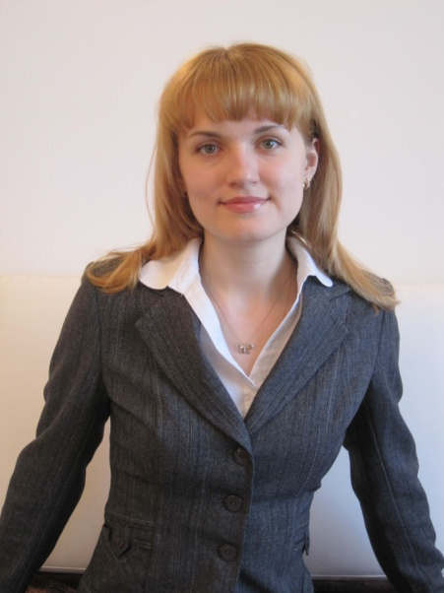
Victoria Khevavasam
Language pairs:
From Finnish to English
From Finnish to Russian
From English to Russian
From Russian to English
Diploma: Master’s degree in translation
Experience: over 6 years
Address: Metsämiehenkatu 17 as. A, 53300 Lappeenranta, Finland
Mobile: + 358 44 975 2874
E-mail: vivagus@gmail.com; victoria.khevavasam@gmail.com
Skype: Victoria.khevavasam

Professional Skills:
- Translation and interpretation in the following subject areas:
- Business and general correspondence (emails, phone calls, certificates, presentations, business correspondence, official documents with apostille, business plans, speeches);
- Medicine/life sciences (clinical trials, IBs, Protocols, patient files, pharmaceutical industry, dental records, medical reports, research papers, health insurance claims, surgical records, medical transcriptions, health care invoices, consent forms, drug information leaflets, other medical and health care information and printed materials);
- Legal (contracts, power of attorney, last wills and testaments, legal proceedings, collection documents, legal correspondence, laws and regulations, general terms and conditions, meeting minutes, commissioner reports, certified legal translations, deeds, judgments,etc.)
- Technical (industry, heavy machinery, metallurgy, technical specifications and manuals, etc.);
- Financial (banking, accounting, bookkeeping, investments, taxes, economics, etc.)
- Marketing and Sales (video and audio, product information, online advertisements);
- Computers, IT and telecommunication
- Human Recourses
- Consecutive interpretation
- E-mail and website translation
- International phone calls support and interpretation
- Russian and English texts proofreading
- CAT tools (SDL Trados, Word Fast
Education Summary:
- The Ural Federal University. Department of foreign languages.
Web-site: http://www.ustu.ru
Major: Linguistics and interpretation.
Diploma: Master’s degree in translation and interpretation of foreign languages.
- 2009-2010 – USA exchange program traineeship
References: Patricia O’Shea White
Address: 43 Bay Drive, Annapolis (MD), USA, 21401.
Tel.: +1 (410)-268-25-94
E-mail: pat@whitehouseonthebay.com
- 2013, 2014 – traineeship in Great Britain (clinical trials translation)

Work Experience:
2012-present | Translation agency “Yes we can”  Fin-Eng, Fin-Rus, Eng-Rus, Rus-Eng, Fr-Rus translator, proofreader, various translations  Website: http://www.ywec.ru/
2015-present | Translation agency “Expert”  Eng-Rus, Rus-Eng proofreader and copywriter
2013-2015 | InVentiv Health Clinical  Eng-Rus, Rus-Eng translator, site contracts, medical and clinical trials translation  Website: http://www.inventivhealthclinical.com/
2011-2013 | Worldwide Clinical Trials  Eng-Rus, Rus-Eng translator, coordinator, business, medical and administrative translation  Website: https://www.worldwide.com/
2009-2011 | JSC “Sinarsky Pipe Works”  Websites: www.tmk-group.com, www.sintz.ru.  Position title: Rus-Eng, Eng-Rus translator
02.05.10 – 02.16.10 | Consecutive interpretation (English-Russian) at Pr. Stephen Hapell’s («Triskem» Laboratory, France) seminars and master classes on the problems of Ra- and U- samples industrial refining and their α-β-spectrometry

Extra Information:
- Computer literacy: Windows (ХP, Vista,7), Linux, MS Office, Internet
Explorer, Opera, Google Chrome, Photoshop, Adobe Premier Pro,
software / operating system installation.
- Business trips (including long-term) are possible. Valid international passport and Schengen visa.
- Personal skills: sociability, responsibility, reliability, industry, team-player

