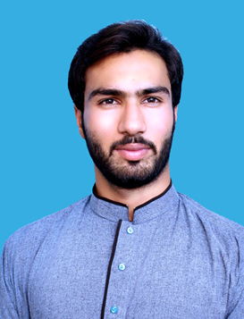
Uzair Khan
Work Title

Phone: 092 3139561445
Adress: Gull Colony, Peshawar Suburbs, Pakistan
Email: zairo710@gmail.com

EDUCATION PROFILE

Education (2011 - 2013)
FSc in Pre-Engineering from University of Peshawar,
Pakistan.

Education (2013 - 2017)
English Literature and Linguistics (Master’s degree)
from the Bacha Khan Univeristy, Charsadda, Pakistan.

Education (2020 – Cont.)
English Literature (Mphil)
From National University of Modern Languages (NUML), Islamabad, Pakistan.

WORK
Dedicated English to Pashto/Urdu and vice versa translator, transcriber and voice over artist with 2.5 years of experience with different clients and agencies. I am well-talented and have the ability to transfer the exact meaning of the source language taking into consideration the culture of the reader receiving the final text. I am multi-tasking and aware of several cultures across the world.

Work Place (Oct, 2017 – Oct, 2020)
Title
Lecturer English at the Quaid e Azam Group of Schools & Collges, Peshawar, Pakistan.

Workplace (July, 2018 – Dec, 2018)
Title
English to Pashto Translator, Reviewer and Lead Reviewer with TAUS-The Language Data Network.

Workplace (Jan, 2019 – March, 2019)
Titel
English to Urdu Translator with Audiobee.

Workplace (Feb, 2019 – July, 2019)
English to Urdu Translator & Transcriber with J. Distribution at TAUS-The Language Data Network.

Workplace (June, 2019 - Jan, 2020)
Pashto to English Transcriber with Advanced Language Systems International.

Workplace (April, 2020 – Dec, 2020)
Voice Over Project Manager with a Chinese Company for Urdu, Dari, Persian, Arabic (UAE, KSA, Iraqi), German and some African Languages.
Workplace (July, 2020 – Present)
Pashto/Urdu to English Transcriber. Project Manager of Pashto, Urdu, Punjabi, Dari, Persian [Afghanistan], and Arabic langauges with Project Lingua.

SKILLS

MS Office: (Word, Powerpoint, Excel)

CAT Tool: SDL Trados Studio

INTERPERSONAL

- Fast and efficient learner
- Good team player
- Result-oriented
- A punctual worker
- Reliable and responsible with all tasks,
Whether big or small.

REFERENCES

Available on request.

