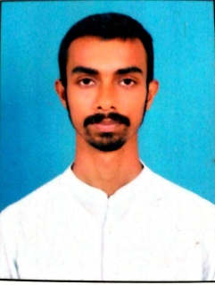
UJJWAL MONDAL

E Mail: – ujjalt8@gmail.com
Contact: (Mob.)8017453615/ 7001197019

CAREER OBJECTIVES

- To be a successful professional
- To achieve perfection in work
- To progress in my work place

EDUCATIONAL CREDENTIAL

2015-2018 B.A Honours with journalism & Mass Communication from Sealdah Surendranath College under Calcutta University with 58% marks.

2015- Higher Secondary from WBCHSE with 78.8% marks.

2013- Madhyamik from WBBSE with 78.28% marks.

WORK EXPERIENCE

- Former trainee output producer at ANM News.
- Assistant Producer at ANM News.

SOFT SKILLS
- Email & Internet Operating.
- Microsoft Word, Excel, PowerPoint, Photoshop, Quarkxpress.
- Sree Lipi

HOBBIES

- Copywriting.
- Photography.
- playing Cricket and Football

INTERESTS

- Reading Newspapers.
- Surfing Internet.
- Listening to news in Radio and Television.
- Communicate with people.
- Anchoring

STRENGTHS

- Good Communication Skills to Interact.
- Smart, Talented & Dynamic, to play a positive role in a challenging environment.
- Urge of Learning from every part of Life.

LINGUISTIC PROFICIENCY

@ Bengali
@ English
@ Hindi (speak)

COMPUTER KNOWLEDGE

- Microsoft Word, Excel, PowerPoint, Photoshop, Quarkxpress.

PERSONAL MINUTIAE: Date of Birth: 14th December,1996

- Address- Natagachi, P.O- Beniabow, P.S – Sonarpur,
pin- 743613

- Father’s Name- Mintu Mondal

- Mather’s Name- Maya Mondal

- Marital Status- Single

- Nationality- Indian

- Religion- Hindu

- Caste- SC

EXTRA CURRICULAR ACTIVITIES

Completed 4th year from Sarbabharatiya Sangeet & Kala Mandir in Art & Painting.

DECLARATION

I hereby Declare that all the information furnished above are true to the best of my knowledge.

UJJWAL MONDAL. DATED. 16/05/2020

