CURRICULUM VITAE

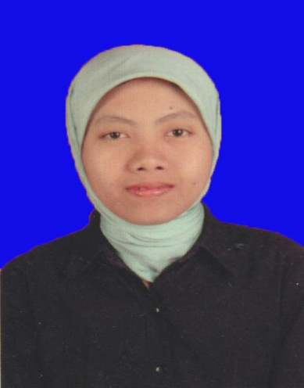

NAME : Trisna Dewy
ADDRESS : Perum Talaga Bestari Blok L8/28 Balaraja Kab. Tangerang
PHONE NUMBER : 0812-1008-9527
EMAIL ADDRESS : trisnadewy123@gmail.com

Services : Translating from English into Indonesian and Vice Versa, Editing Translation from English into Indonesian
Mother Tongue : Indonesian
Source Language : Indonesian, English
Target Language : Indonesian, English

SPECIALISATIONS
General : Current Affairs, Psychological Text, Text of Journalism
Literature : Novel, Short Story, Poem
Business : Marketing and Economic Text
Legal : Legal Texts
Medical : Medical Articles
Science : Popular Science Books

EXPERIENCES
Freelance Translator (2004- 2006 & 2012-Now)
Post Production Staff at TRANSTV (April 2006-August 2014)
English Teacher at SDN 01 Ampang Padang (July 2005-December 2005)
English Teacher at SDN 30 Lb. Lintah Padang (July 2005-December 2005)

EDUCATION
Postgraduate Degree from University of Indonesia Major in Translation (2015)
Graduate Degree from English Department Bung Hatta University Padang (2005)

