Personal Information: | Temesgen Biyi Dinsa
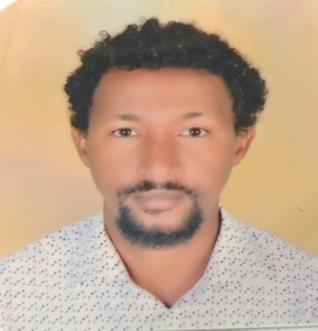 | P.O. box 395, Wollega University, Nekemte, Ethiopia
 | +251964199288
 | tamidinsa@gmail.com
 | Sex : Male/ Date of birth : 19 /10 /1988 / Nationality : Ethiopian

JOB APPLIED FOR  POSITION: | Translation and Revision as a freelancer

Work Experience: - Assistant Lecturer: Wollega University, Nekemte, Ethiopia
(2018 –until now)
- Teaching, community service, researcher
- Nekemte preparatory school and Bethel academy School,
Nekemte , Ethiopia (2009 - 2019 G.C )
- Teaching, Charity Work (community organizer)
EXPERIENCE AS  A TRANSLATOR: | I have more than 5 years of experience on translation with both local & international companies. I work on three languages, English, Amharic, and Oromo. I have good command of the three languages. For the last 5 years, I have been working with Babelos international on Social posts project and many other projects. With them I have translated around 800,000 words, both English to Amharic and English to Oromo. I also worked on reverse translation from Oromo and Amharic to English. I have also worked with other agencies like db intl group, transparent intl group, Somya intl group, Stepes.Com, Universal Translation Services, Motaword, Smart cat, up work, translation café, Translated SRL and translationdictionary.com. In addition to translation, I also work on transcription, editing, proofreading, and subtitling activities. For this work, I can use different tools like, Dejavux, Grammarly, SDL Trados, IBM CAT tool, MemoQ, smart cat, Mate Cat.

Mother Tongue(S): | Oromo and Amharic languages (bilingual)
Other language(s) | UNDERSTANDING |  | SPEAKING |  | WRITING
 | Listening | Reading | Spoken interaction | Spoken production
English | Excellent | Excellent | Excellent | Excellent | Excellent
EDUCATIONAL & TRAINING:
Grade Attend | Name of school | Years of Study(GC) | Diploma Award
12+ 4 | Bahir dar University | 2005/6- 2009 | BSc in Chemistry
Master | Gondar university | 2016/7-2019 | MSc in organic chemistry
12+ 5 | Wollega University | 2010/11-2015 | BSc in pharmacy
Master | Jimma University | 2021-2023 | Msc in Pharmaceutical supply chain management

PERSONAL SKILLS:
Communication skills: good communication skills gained through my experience as a
teacher, presenter and community organizer
Job-related skills:
- Excellent ability to deliver the work efficiently
- Excellent ability to submit tasks on time
- Flexibility in solving problems during the work
- Excellent ability to communicate with concerned bodies about the status of the work
- Excellent ability to represent and stimulate interest among fellows.
- Excellent ability to think creatively and propose alternative approaches.
- Excellent managing and team leading skills
- Excellent facilitating and team coordinating skill.
ADDITIONAL INFORMATION:
Certifications: Higher Diploma program, Computer skills, Problem based Learning

REFERENCES:
- Mr. Tesfa Dibessa (Msc) , leader of pharmacology unit , Wollega University, Nekemte, Ethiopia
E-mail: tesfabon@yahoo.com
Mobile: +251-910101409
- Mr. Mohamed Gebre (Msc.), Head department of Pharmacy, Wollega University, Nekemte, Ethiopia
E-mail: -mohamedg@wollegauniversity.edu.et;
gebremohammed@yahoo.com
Mobile: +251913299044
- Mr. Balisa Mosisa(B.Pharm), Department of Pharmacy, Wollega University, Nekemte,
Ethiopia.
E-mail-balisamosisa@yahoo.com
Mobile- 0913299044
4. Dr. Desta Shumiye, College of natural & computational sciences, educational & quality
assurance directorate, department of chemistry, university of Gondar , Gondar
E-mail:destawnano2009@gmail.com
Mobile: +251920969620

