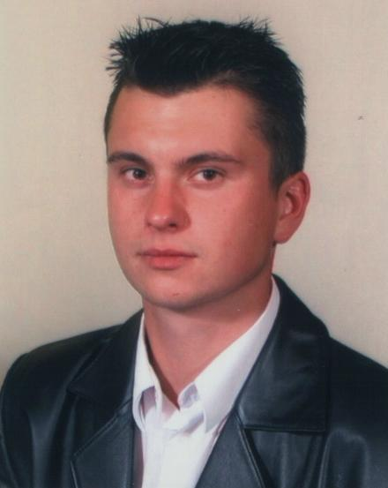Tomasz Poniedzielski
Residence address:
Świętokrzyska 8
28–200 Staszów
GSM: 504 663 920
tomasz.poniedzielski@wp.pl
Date of birth 26.01.1983
Place of birth: Staszów

Education

2010 – in progress – Polonia University in Częstochowoa, The Translation and Interpretation Institute,
Field of study: Sworn translations, sworn interpretations
Speciality: Sworn translator; Sworn interpreter

2006 - 2009 – The Jagielloński University, European Faculty in Cracow,
Field of study: International and Political Relations;
Speciality: European Integration

2003 – 2006/2006 - 2008 The University of Arts and Sciences in Kielce
Field of study: English Studies;
Speciality: Business teaching,

1998 – 2002 Classical High School named after S. Wyszyński in Staszów
Subject: science
Professional experience

01.01.2011 – w trakcie - Elektrownia Połaniec S.A. – Grupa GDF Suez Energia Polska
in Zawada, Customer Service Department – Katowice, Customer Service Specialist; opereting within the field of financial, invoicing and HR programs: SALIX, LUX and SAP, energy sell/purchase invoicing and drawing up reports, translation of documentation (English), preparing correspondence, assistance during the implementation of cooperation strategies with Suez Group, preparing articles and pictures for newspapers and cooperation with radio station, secretarial duties, keeping records of operations and coordination, article proofreading for printing, web site and intranet managing, special corporate organization of cultural and company events, performing a wide variety of general clerical work.

16.03.2010 – 16.09.2010 – Elektrownia Połaniec S.A. – GDF Suez Energia Polska S.A. in Zawada, Organization and Management Department, Public Relations, organizational agent, translation of documentation (English), preparing correspondence, assistance during the implementation of cooperation strategies with Suez Group, preparing articles and pictures for newspapers and cooperation with radio station, secretarial duties, keeping records of operations and coordination, article proofreading for printing, web site and intranet managing, special corporate organization of cultural and company events, performing a wide variety of general clerical work.
- Translation of technical weekly reports for the GDF SUEZ Group,
- Translation of reports and materials concerning the Green Power Unit in GSEP,
- Interpreting during teleconferences with GDF SUEZ H&S headquarters,
- Translation of correspondence concerning wide range of topics, including following issues: technical, labour, HR, financial, social, H&S, PR, as well as motions and applications for meetings of the GSEP Management Board,
- Providing help to employees from all GSEP departments in communication and English correspondence interpretation.

01.09.2009 –31.01.2010 – Świętokrzyskie Voivodeship, Marshal Office, Department of Regional Policy, white-collar worker department manager, archiving, working among the field of SOP and ROP of Świętokrzyskie Voivodeship 2007 – 2013, providing potential clients with information concerning EU funds for operational programs, Świętokrzyskie Voivodeship ERDF projects, co-operation with other Office Departments, office equipment operation, preparation and edition of official documents, data computerization, translation of documents English – Polish, Polish – English, acquiring basic knowledge of law regulations concerning Operational Programs, UE funds, correspondence administration, getting familiar with job specification of Department of Regional Policy and terms connected with administration, office, chancellery and applicant service.
01. – 06.2009 – web site administrator in Rzeszowski Katalog Firm (rzkf.pl). Responsibilities: system administration, system advertising, customer service
11.2005 – 03.2006 – trade co-partner in Telekomunikacja Polska S.A. Lublin, Section in Kielce
2006 - Teacher practice in high school in Połaniec, teaching English
07. – 09.2004 – “Lech” hotel in Łeba, receptionist, consumer service, mainly English speaking customers, planning hotel’s strategy and reception staff managing, references
Active participation in students’ organizations (taking part in artistic events and arranging excursions, trips); part – time, odd jobs and seasonal jobs during studies, child’s foster-father on summer camps.
Languages

English – fluent
German; Russian – basic

Additional qualifications and strengths

Driving licence category B (since 2000)
Child’s foster-father diploma
Computer skills course: Office, Adobe Photoshop, Corel, internet
Excellent analytical and evaluative skills
Perceptive, efficient, patient, and understanding
An excellent listener and communicator
Relates well with a wide variety of people
A quick thinker

Interests

motorization, parties organizing, travelling, European integration, squash, team sports, athletics, rock and pop music, cinema, photography, geography, cultural science, meeting new cultures and people

“In spite of recruitment requirements I herby give my permission to process my personal data as included in my offer (under the act from 29.08.1997 regarding Personal Data Protection; uniform text: Dz. U. z 2002r. Nr 101, poz. 926 ze zm.).”
"Wyrażam zgodę na przetwarzanie moich danych osobowych dla potrzeb procesu rekrutacji zgodnie z Ustawą z 2002 roku o Ochronie Danych Osobowych (Dz. U. Nr 101 poz, 926 ze zmianami)".

