NGUYEN VU THUY DUNG 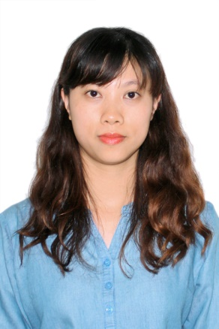
71 Truong Cong Dinh – Ward 1 - Dalat
079 754 0121
thuydung.nguyenvu@gmail.com
Position applied: English – Vietnamese Translator
and Vietnamese – English Translator
CAREER OBJECTIVE
skilled translator
TYPICAL CHARACTERISTIC
Have a high sense of responsibility
Patient
Enthusiastic
EDUCATION BACKGROUND
• IELTS : 7.0
Writing: 7.5
Reading: 7.0
Listening: 6.5 Speaking: 6.0
• Bachelor of Ha Noi Open University
Major: Business Administration
FOREIGN LANGUAGE
English
EMPLOYMENT
ENGLISH TEACHER (2013 to NOW)
• Teaching English at Aptech English Learning Academy and Study Smartly with Loc Minh English Center
• Being a self-employed English teacher at home.
Teaching for wide range of classes:
English for high school students
English communication courses for teenagers (A2, A2+,
B1)
English for IELTS, TOELF, FCE
English for children
TRANSLATOR (2017 to NOW)
• Contributing Translator of TED and Scientific American
Translating and making subtitles for videos in a lot of
fields such as: science, education, sociology.
- Freelance translator at translation website expertrans.com
HOTEL MANAGER (2010 to NOW)
• Being responsible for business with online booking
companies such as agoda.com, booking.com,
traveloka.com, mytour.com, ivivu.com.
• Making transactions with foreign companies.

REFEREES
• VU THI XUAN
Director of PX Hotel
62 Phan Dinh Phung – Ward 1 – Dalat
01677032796
• Ms PHUONG LOAN
Director of Aptech English Learning Academy
25/2 Hung Vuong – Ward 10 – Dalat
097 580 3382
- Ms LOC MINH
Director of Study Smartly with Loc Minh English Center
Lô LK1 KQH Đoan Thi Điem - Ward 4 – Dalat
0918249549
HOBBIES
Reading books
Playing sports
Listening to music
SPEACIAL SKILLS
Playing guitar

