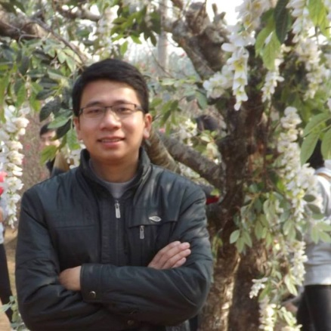 | Curriculum Vitae  Hoang Van Thuy

PERSONAL DETAIL

Full name | Hoang Van Thuy (Mr)
Date of Birth | 20/01/1990
Place of Birth | Ha Noi city
Marriage Status | Married
Nationality | Viet Nam
Address | Tam Hiep commune– Phuc Tho district - Ha Noi city– Viet Nam
Mobile Phone | +84 0973466853
Email | hoangvanthuy90@gmail.com

RESEARCH INTERESTS

My areas of interest are:
- Computers and softwares
- Translating English to Vietnamese

EDUCATION

2021 | Studying English at Hanoi University.
Jan 2017- Dec 2018 | Master’s Degree in Information System, Le Quy Don Technical University, Ha Noi city, Viet Nam.  Thesis Title: “Automated Program Repair based on machine learning technique”  Thesis mark: 8.4 (10 scale)  GPA: ~ 8.2
Sep 2008- Dec 2013 | Bachelor’s Degree in Information Techlonogy, Le Quy Don Technical University, Ha Noi city, Viet Nam.  Thesis Title: “Combining Neural Network and Fuzzy C Means for building a dataset for intrusion detection system”.  Thesis mark: 9.8 (10 scale)  GPA: 8.12  Graduation Classification: Very Good

PUBLICATION

I have published 3 papers on international conferences:
Oct 2018 (accepted) | Thuy Hoang Van, Anh Phan Viet, Hoai Nguyen Xuan, “Automated Large Program Repair based on Big Code ”, the 9th International Symposium on Information and Communication Technology (SoICT), 2018.
Jun 2018 (accepted) | Ly Vu, Hoang Van Thuy, Uy Nguyen, Tran Ngoc, Diep Nguyen, Hoang Dinh, Eryk Dutkiewicz, “Time Series Analysis for Encrypted Traffic Classification: A Deep Learning Approach”, The 18th International Symposium on Communications and Information Technologies (ISCIT 2018)
Dec 2013 | Cao, V., Hoang, V.T. and Nguyen, Q.U., 2013. A scheme for building a dataset for intrusion detection systems. In the 2013 Third World Congress on Information and Communication Technologies (pp. 120-132). IEEE.

SKILLS

- Able to work well with other people.
I certify that the foregoing statements made by me are true.  I am aware that if any of the foregoing statements made by me are willfully false, I am subject to punishment. |  | Date: May 2021.  Signature:  Hoang Van Thuy

