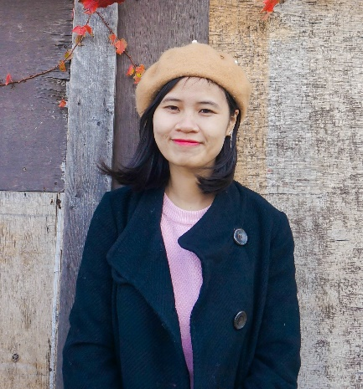
HELEN HOANG
黃虹安

June – 28th – 1992  Translator–Customer Service staff  CONTACT:  - Mail: hoangquanhftu@gmail.com  - Mobile: +886 - 0976629893  - Line ID: shimkedo1802  - Taoyuan, Taiwan  HOBBIES  • Travel • Photograph  • Music • Writing  SKILLS  - Microsoft Office  - Video Subbing – Editing  - Team Work | EDUCATION  - 2017 – present| YuanZe University, Taoyuan, Taiwan  Master student in Foreign Languages and Applied Linguistics Department  - 2010 - 2014 | Foreign Trade University, Hanoi, Vietnam  Degree of Bachelor in Economics (International Trade)  - 2007-2010 |Nguyen Trai Gifted high school, Haiduong, Vietnam  Gifted in French  EXPERIENCE  - 2018 – present: DongA Vietnamese Bank in Taiwan(Yangmei)  Translator–Customer Service staff (part-time)  - 2017 – present: Eazigo Taiwan and Just Travel Taiwan  Freelance Chinese – Vietnamese Translator and Tour guide  - 2016 – 2017: Alitech Technology and Communication Company –  Purchasing Staff – Customer Service Staff  - 2015 – 2016: ThuongDo Logistics Company  Customer Service Staff – Documentation Staff  - 2014 – 2016: VNG TV Zing Channel  Freelance Chinese Translator – Video Subtitle Team  LANGUAGE SKILLS  - Vietnamese: Mother tongue  - Chinese : Advance  - English: Intermediate  - French: Pre-intermediate

