Tatiana Glazina  Certified and sworn translator  Language pairs  GER-RUS ENG-RUS  RUS-GER RUS-ENG | 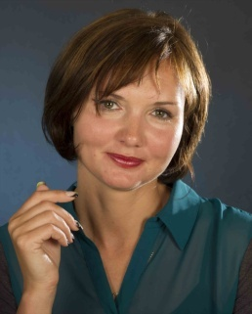

Date of birth 06.08.1977
Place of birth Barnaul, Russia
Address Steinweg 18
59510 Lippetal-Nordwald
Germany

Contact:
Tel.: +49 29239 722735
Mobil: +49 1729782176
Fax.: +49 29239 971887
Skype: tatyana.glazina1
Email: tglazina@gmail.com
Web: www.aufrussisch.de
Translation fields

- Law
- Economy
- Contracts
- Business correspondence
- Marketing and advertising texts
- Food and beverage industry

- Tourism
- Ecology and environment
- Insurances
- Websites
- Psychology
- Education

Software

- MemoQ2015
- Across v.6.3
- SmartCat
- MicrosoftWord
- MicrosoftExcel

Education
1995-2001 Barnaul State Pedagogical University, Russia, Faculty of Foreign Languages, teacher of English and German as a foreign language
2002-2005 Altay State University, Russia, Faculty of Law
2013 Landesspracheninstitut Bochum (Bochum University Institute of Intensive Language Training), Translator of Russian and German in the fields of economy, law and politics (training course).
April 2014 Certified as a Russian-German / German-Russian translator in the fields of economy, law and politics by the Chamber of Industry and Commerce of Düsseldorf, Germany
2014 Certified as a sworn Russian-German and German-Russian translator by the Higher Regional Court Hamm in Germany

Professional Experience
German-Russian and Russian-German translator and interpreter at the Barnaul Distillery JSC in Barnaul, Russia, 2001-2003
- Translation of installation and maintenance manuals
- Translation of product information and certificates
- Translation of business correspondence
- Translation of the website
- Negotiation interpreting
- Telephone interpreting
English-Russian and Russian-English translator at Agrovodprom Ltd, Russia, an international wholesale trader in polypropylene products, 2003-2004
- Translation of installation and maintenance manuals
- Translation of dispatch notes, invoices and customs documents
- Translation of contracts
- Translation of business correspondence
- Negotiation interpreting
- Telephone interpreting
2005-2007 Sales manager for the software product "ConsultantPlus", a business information solution developed as a system of law and finance consulting for private and business partners including governmental, regional and federate authorities, courts, educational institutions, banks and enterprises of all kinds.
Freelance German-Russian and English-Russian translator, 2007-2010
- Certificates
- Contracts
- Insurances
- Instruction manuals
- Other texts
2010-2011 Moving to Germany for family reasons
From 2014 Freelance German-Russian and English-Russian translator

- Certificates
- Contracts
- Court documents

