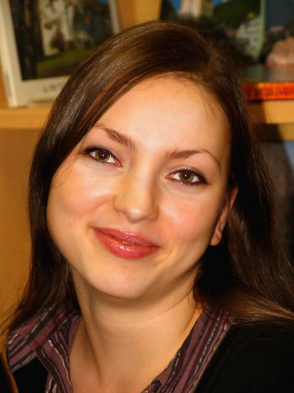 | Tamara Yurovskaya  Professional translator/interpreter  Language pairs: BG-RU, RU-BG,  EN-RU, EN-BG | GSM: +359895821380  Viber: +359884837797  Skype: bolgaroff-tour  Email: tammie@yandex.ru  Web : https://www.proz.com/profile/1543288
WORK EXPERIENCE
Freelance translator/interpreter
2010 to Present
Working languages: Russian, Bulgarian, English
Specializations:
- Tourism & Travel
- Anthropology
- Law: Contract(s)
- Real Estate
- Archaeology
- Insurance
- Religion
Cooperation with multiple translation agencies and publishing houses:
Translation agency “Tradosonline”, Sofia, Bulgaria  Translation agency “Unlimited”, Sofia, Bulgaria  Language centre “Martin Luther”, Plovdiv, Bulgaria  Translation agency “Eko-4”, Bulgaria | Publishing house “Eksmo”, Moscow, Russia  Publishing house “Agency of contemporary specialists and authors”, Kharkiv, Ukraine
EDUCATION
Bachelor of Philosophy Saint Petersburg State University – Saint Petersburg, 2002 to 2007
Publications
Russian-Bulgarian Phrasebook
Eksmo, Moscow, Russia
October, 2013
Russian-Bulgarian Phrasebook & Guidebook
Eksmo, Moscow, Russia
July, 2013
Software skills:
MS Office, SDL Trados Studio, Adobe Acrobat, Photoshop, DejaVu

