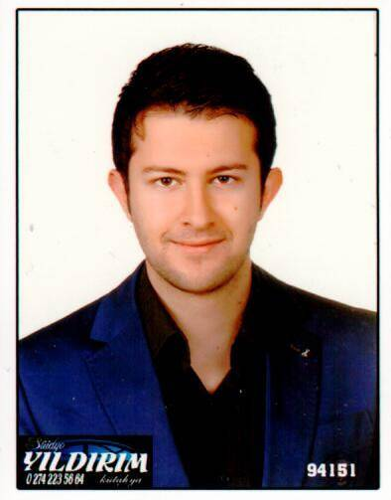
Taha NAGANLU, 31.07.1993
ADDRES GSM
E-MAIL
WHATSAPP SKYPE
LINKEDIN

: Sisli/ İstanbul
: 00-90-555-253-45-67
: tNaganlu@gmail.com
: 00-90-555-253-45-67
: tnaganlu
: https://www.linkedin.com/in/taha-naganlu-1a0a1693/

COURSES AND CERTIFICATES

Cervantes Spanish A2 Language Course Certificate
Cervantes - İSTANBUL (2020)

International Outstanding Student Certificate
Beijing Institute of Technology – CHINA (2015)

Chinese Proficiency Test (HSK Level 5)
Confucius Institute – BEIJING (2015)

EDUCATION

Post Graduate – Tourist Guide (2018-2019)
Osmangazi University, (Eskişehir)

Sinology – (2014-2015)
Language University, (Pekin)

Chinese Language and Literature - (2011 – 2015)
Erciyes University, (Kayseri)

High School (2009 – 2011)
Fatih Anotalian High School (Kutahya)

WORK EXPERIENCES

IZ TRANSLATION CONSULTANCY TRANSLATION SERVICES

Certified Public Translator ( August 2016 – Now)

Job Description:

√ Bringing freelance solutions to the English, Chinese and Turkish translations of İz Translation in Pendik, Kaynarca, Gebze districts.

FLEX TOURISM TRADE AND TRAVEL JOINT STOCK COMPANY
Professional Tourist Guide (July 2017 - Now)

Job Description:
√ To provide professional guidance services in their own language to tourist groups coming from abroad during their tours and to send them to their countries in a healthy way.

HUAWEI TECHNOLOGIES CO.LTD.

Solar Power Inverters European Business Development Department

Sales and Marketing Coordinator ( May 2016 – April 2017 )

Job Description:
- Social media phenomenon, media and sectoral media management. (Facebook, Linkedin, Twitter...) (Facebook, Linkedin, Twitter…)v
- News, Advertising and New Product Advertising publications. (Yenienerji, Solarbaba, Günder)
- Special seminar organizations for investors.
- Domestic and foreign headquarters and factory tour organizations.
- Management of contracts in Turkey;
- The process from the conclusion of the contract to the procurement of the product to the customer.
- Distributor Management
- Management and support of distributors to help sales within Turkey.

ÖZİDEAL SADDLERY CON.DUR.GDS.IND.TRD.LTD.
Foreign Trade Chief – ( December 2015 – May 2016 )

Job Description:
- Importing from Asian countries such as China (Hongkong, Singapore, Taiwan), Korea, Japan, as well as countries whose native language is Spanish. Preparing customers' orders and receiving their feedback, providing timely product supply, importing documents, reports, etc. to follow up the shipment process by preparing. Developing existing export channels, finding new export channels and conducting market research. To ensure the satisfaction of existing customers, to find new customers.
- Participating in international fairs, visiting distributors and customers when necessary.
- To follow the latest products and models in the countries of responsibility, marketing activities and preparing reports.

SAMSUNG RESEARCH AND DEVELOPMENT CENTER BEIJONG OFFICE
Intern - Interpreter – ( March 2015 –July 2015)

Job Description:
- Make market research in Turkey.
- To control all English and Turkish texts.
- Developing and implementing sales and marketing strategies.
- Using digital marketing tools and social media to promote products and programs and increase awareness.

FOREIGN LANGUAGES:
Chinese: Advanced
English: Advanced
Spanish: İntermediate
Turkish: Native

REFERANCES:
- Iz Translation/ Sevgi Durmuş/ Executive of Gebze Office/+90 553 002 21 81
- Flex Tourism/ Gülay Demir/ Executive of Company /+90 535 301 25 00
- Huawei Technologies/ Arlen / Executive of Turkey Department/+90 541 836 38 81
- Ozideal Saddlery/ Berkay Ayrancı/ Executive of Company/+90 543 216 59 77

AREAS OF INTEREST:
- Self-improvement
- Internet, social entertainment
- New marketing strategies, import-export
- Learning foreign languages
- Sport activities
- To travel
- Art history and archeology
- To follow cultural and artistic activities

