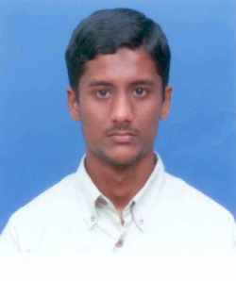
Syed Ehsanullah
Mobile: 919629133212
Email: Ehsan407@gmail.com

PROFESSIONAL PROFILE
A conscientious, diligent, dedicated and hard-working person possessing excellent communication, interpersonal and with appreciable experience in teaching field, an individual who demonstrates a passion for the motivation and development of company. A realistic team member who creates an inspiring and exciting environment and maintains strong relationships with colleagues, and administration.

CAREER SUMMARY

2005-2006: Arabic languageTeacher, Islamic International School, Chennai, INDIA
2007-2009 : THE MILLENNIUM SCHOOL, DUBAI
ARABIC LANGUAGE TEACHER, (Arabic to English teaching)
2010- 2011: Arabic language teacher, olive international school, )IGCSEChennai
2012-till date Arabic language professor in islamia women’s college ,pernambut
Translator –Inspace technologies, Anna nagar, Chennai, india .
- Responsible for teaching for classes primary and secondary
- Providing a motivational learning environment through managing multi-cultural people,
- Collaborating effectively with colleagues as part of a cohesive and professional team
- Demonstrating excellent communication skills

EDUCATIONAL QUALIFICATIONS
BA: Major: Arabic Literature (University of Madras, India, 2006)
Certificate in Arabic language : Major: Arabic literature (Jamia Darussalam, Arabic college,)
MA: Major Arabic literature (University of Madras,india 2011-12
FURTHER SKILLS
I.T. Proficiency: Diploma in Computer Application & Typing English and Arabic Higher Level
Languages: English, Arabic, Urdu, Hindi, Tamil.

PERSONAL DETAILS
Name : Syed Ehsanullah
Date of Birth : 28/10/1985
Nationality : Indian
Marital Status : married
Passport Number : F8547577
Place of Issue : Chennai – India
Date of Issue : 11/07/2006
Date of Expiry : 10/072016
Reference : Will be produced on demand.

