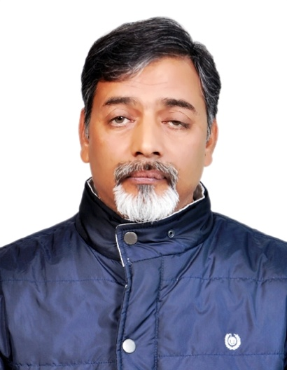  Surendra Pratap  Expert in Translation, Transcription, Editing and Copy writing for two languages: Hindi and English  Expert in Research, training and capacity building  Expert in Social Audits  Address: 305-B, Pocket-N, Sarita Vihar, New Delhi, India  Email: spsurendrapratap@gmail.com  Skype: surendra.pratap1  Phone: +919711381113 | Education
Masters Degree in Economics, 2000; BR Ambedkar University, Agra, India
Masters Degree in Environmental Sciences, 1987; GB Pant University of Agriculture & Technology, Pantnagar, India
LLB (Bachelor of Laws), 1995; Lucknow University, Uttar Pradesh, India
Bachelor of Science, Zoology, Forestry, 1984: Kumaon University, Nainital, India
 | Experience
- Translation, Transcription, Editing and Copywriting

I am engaged in translation and transcription work for more than a year (freelance)
I worked as Sub Editor in a Hindi daily-Dainik Jagaran for about 4 years (2002-2006).
I have been engaged in writing pamphlets and slogans for NGOs and people’s movements (freelance)
I wrote as well as edited many research papers for books mainly published by AMRC
I am engaged as reviewer in Journal of Labor and Society and Journal of Contemporary Asia, and reviewed some papers from time to time for both journals

- Research
I have been working as researcher for more than 10 years
My research is focused on political economy of labour, Industrial relations and social exclusion
I have researched both formal and informal sectors
I have written 2 books
I have published more than 25 research papers in national and international journals
(Pl see the link of books and some papers appended)
- Training and Capacity Building
I have been engaged in training and capacity building for almost 10 years
More focused on Training and capacity building programs for labour NGOs and people’s movement groups
Focus areas: Organizing the unorganized, social security, Business and Human Rights and various ILO standards
- Social Audits
I have been working as member of Fair Wear Foundation (FWF) Audit team for about 10 years
I have also been working as FWF complaint handler, receiving the complaint from workers and facilitating remediation
I have audited more than 50 factories

Appendix
- Link of my books and some research publication

- Emerging Trends in Factory Asia; https://www.amrc.org.hk/content/emerging-trends-factory-asia-international-capital-mobility-global-value-chains-and-labour
- Worker Cooperative in India; https://www.palgrave.com/gp/book/9789811303838
- Liberalisation in India: Does it Resolve or Aggravate Employment Problems?; https://www.tandfonline.com/doi/abs/10.1080/00472336.2018.1545916?forwardService=showFullText&tokenAccess=xw58D4fpEG4FyKg9zPun&tokenDomain=eprints&doi=10.1080%2F00472336.2018.1545916&doi=10.1080%2F00472336.2018.1545916&journalCode=rjoc20
- India’s Informal Sector: Demystifying a Problematic Concept, https://www.onlinelibrary.wiley.com/doi/abs/10.1111/wusa.12232
- Sample Translation /Transcription Works
Samples can be provided when required

