Sundus Khalid Aljanabi
Address: Al-Rabia, Amman, Jordan
Postal Code: 11195 Amman, Jordan.
Cell phone: +962795466764
E-mail :sundustranslation@gmail.com

To whom it may concern
I am an Arabic native speaker living in Amman/Jordan for the past 10 years. In recent years I have been working as a freelancer translator, and I am seeking more opportunities in this field.
I have finished my bachelor study in Baghdad (College of Art, University of Baghdad), and got my MA degree in translation from the University of Petra in Amman Jordan.
Providing translation services for major companies and organizations like PWC Amman and Dubai added a lot to my experience, At the moment I am mainly providing transcription services and proofreading in various fields; business, art, sports, media etc.
What I like most about this job is that it gives me the opportunity to learn and be skillful, looking forward to hearing from you soon.
Regards
Yours sincerely
Sundus khalid

Curriculum Vitae
For
Sundus Khalid Aljanabi

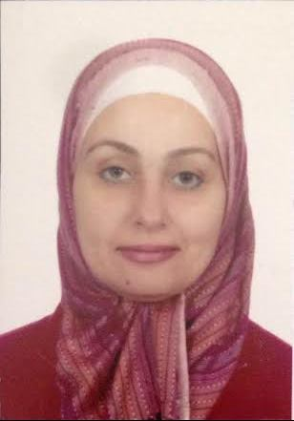
Date of birth: 22th December 1966
Marital status: married
Nationality: Iraqi
Home Address: Al-Rabia, Amman, Jordan
Postal Code: 11195 Amman, Jordan.
Cell phone: +962795466764
E-mail address:sundustranslation@gmail.com
EDUCATION
• Master in English language/Translation (Pertra university-Amman/Jordan 2009) with cumulative grade point average of (3.36 out of 4) Rating (Very Good).
• B.A. degree in English language (University of Baghdad- Baghdad/Iraq 1988) rating (good).
• Passed the Institutional Test Score Record (TOFEL .ITP) (Amidest-Jordan 22th July 2009) with a total score of (507). Individual scores:
• Listening comprehension: 49
• Structure& writing expression: 52
• Reading comprehension: 51
WORK EXPERIENCE
• Senior translator at Al Ma'amoun translation center/Baghdad from March 1989 to May 1992.
Main duties: Translating different types of texts in various fields; health, literature, politics, etc.
Accomplishments
- Translation services and language review for PWC /Amman, Jordan concerning family businesses.
- Translated brochures for PWC/Dubai concerning family businesses.
- Audio transcription services for online organizations.
- Proofreading services for online organizations and transcription.
- Translated many articles from The Economist into Arabic
- Translated more than 200 English proverbs into Arabic by finding their proper equivalent in the target language.
- Ideological shifts in cross-cultural translation (seminar).
- Translated Advertisements.
LANGUAGES
Written spoken
• Arabic Excellent Fluent
• English Excellent Fluent
COMPUTER SKILLS
• Efficient in dealing with Windows, MS office and Internet browsing.
• Familiarity with computer environment; can facilitate rapid adaptation of common software tools as PowerPoint, Excel and Database.

