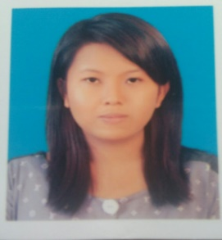
RESUME
PERSONALITY
Name :Ma Su Lae’ Kyaw Thein
Date Of Birth :September 6, 1994
Age :24 years
Nationality & Religion :Myanmar, Buddhist
Gender :Female
Marital Status :Single
Educational Background :BA (Hons in English, Dagon University)
Other Qualification :Certificate of Computer Microsoft Office (2007)
Applying Position :English Translator
Expected Rate :0.04 $ per word, 30 $ per hour
Contact Address :No.123, 9 Street, Nga Moe Yeik Quarter, Thingangyun Tsp, Yangon
Mobile Phone :09962598186, 09251036699, 01-572120
Email :slatt0607@gmail.com
OBJECTIVE
-Seeking for English Translation Field
Key Skill:
- Strong knowledge in English Translation field
- Result oriented, adaptable to new working environment, strong desire to learn and able to work in long stretches and under pressure work environment.
WORK EXPERIENCE
Forever Group Company (MRTV-4) -International News Translator(From Jan,2015 to Dec,2015- 1 year)
Kokorize Myanmar Translation Co., Ltd -English-Myanmar Translator (From Jun,2016 to Dec 2016- Project period)
*Currently, I am working in translation field as a freelancer. So, my working experience is over 3 years long.

