Stela A. Ghetie
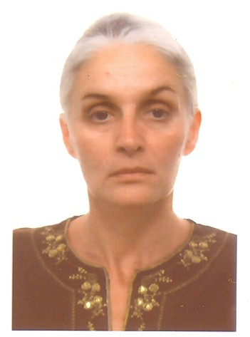
stela.ghetie@gmail.com

Skype stela.alexandra.ghetie

Employment

2012 – present Ecole Mondiale World School, Mumbai, India
IB-DP English A Literature and Theory of Knowledge Teacher
IB-MYP English A and IGCSE Literature and Language Teacher
Free-lance translator Romanian to English and English and French to Romanian (since 1996)

2010 –12 Mark Twain International School, Bucharest, Romania
Head of the English Department
IB-DP English A Language and Literature and Theory of Knowledge Teacher
IB-MYP English A Teacher

2008- 2010 Aga Khan Academy, Nairobi, Kenya
MYP Coordinator (2009-2010)
IB-MYP English A Teacher (2009-2010)
IB-PYP Coordinator (2008-2009)

2001-2008 Mark Twain International School, Bucharest, Romania
Head of the English Department
IB-MYP English A and English High School Teacher (2006-2008)
IB-PYP Coordinator and English Primary and Secondary School Teacher (2002-2006)
English Primary School Teacher (2001-2002)

1999-2001 Primary and Middle School, Colti, Buzau, Romania
English as a Foreign Language Primary and Secondary School Teacher

1996-1998 American International School of Bucharest, Romania
Substitute Primary and Secondary School Teacher

1994-1996 Laramie County Community College, Cheyenne, Wyoming, U.S.A.
English Instructor – English 101, 201, World Drama

1992-1994 North Lake College, Irving Texas, U.S.A.
English Instructor – English Composition 101, 201, Business English, World Literature
Writing Tutor

1988-1991 State University of New York at Buffalo, Buffalo, New York, U.S.A.
Teaching Assistant in the English Department – English 101, 201, World Literature and Short Story
Library Assistant in the Poetry and Rare Books Collection

Education

M.A., Department of English, State University of New York at Buffalo, NY (1991)
Institute of Medicine and Pharmacy Carol Davila, Bucharest, General Medicine (1980-1981)
B.S., College of Natural Sciences C. A. Rosetti, Bucharest (1980)

Professional Qualifications

IB-PYP Consultant and Reader (since 2012)
Currently appointed to Ajman Academy, UAE, working towards verification visit in 2014

IB Workshop Leader for Romania (since 2010)

IB-PYP Visitor B (since 2006)
5 IB-PYP verification and evaluation visits conducted at International School of Munich (2011), Luanda International School of Angola (2009), Tanganyka International School, Dar Es Salaam (2008), Oulu International School, Oulu (2007), and Ressu Comprehensive School, Helsinki (2007)

Texas Examination of Educator Standards (1993)

Professional Workshops

2013 IGCSE English Language 0500, Ahmedabad
2012 IB-DP English A Literature, Chennai
2012 IB-PYP Reader and Consultant Workshop, The Hague
2010 IB Access Workshop Leader Training, Bucharest
2009 IB-PYP Teaching and Learning in the Early Years, co-facilitated workshop with Sam Cook, Nairobi
2009 IB-PYP Concept-based Curriculum, Nairobi
2008 IB-PYP Inquiry-based Learning, Nairobi
2007 IB-DP Introduction to Theory of Knowledge, Athens
2007 IB-MYP Introduction to the MYP, Bucharest
2007 IB-MYP, Assessment in the MYP, Bucharest
2006 IB-MYP Introduction to Language A-English, Basel
2006 IB- PYP Science and Social Studies in the PYP, Cairo
2006 IB-PYP Reading and Writing in the PYP, Bucharest
2005 IB-PYP Towards an International Education, Bucharest
2005 IB-PYP Assessment in the PYP, Bucharest
2004 IB-PYP Inquiry in the PYP, Bucharest
2003 IB-PYP Teaching and Learning in the PYP, Bucharest
2003 IB-PYP Introduction to the PYP, Bucharest
2002 IB-PYP Making the PYP Happen in the Classroom, Zug

Publications

“I do not love thee with mine eyes”. Presentation and article in Deus Loci on the occasion of the Lawrence Durrell Centenary, London (2012)
2 novels (Sabia lui Mihai. Cartea Românească, 2007 ; Salul. Editura Herald, 2009)
2 volumes of poetry (Padurea tacuta. Editura Rosmarin, 1998; Porti. Editura Pontifex, 2009)
Articles in journals Ianus, Caiete de studii tradiționale (1998-2012)
Over a hundred book reviews in Adevărul literar și artistic (2004-2007)
Over 20 translated works from and into Romanian, English and French (1996-2012)

Languages
Bilingual English and Romanian, fluent French

References

Deborah Anderson, Head of Department, Ecole Mondiale World School, Mumbai, India djanderson@ecolemondiale.org
Anca Macovei Vlasceanu, Head of School, Mark Twain Int’l School, Bucharest directors@marktwainschool.ro
Jannie Kleynhans, Principal, Kgaswe International School, Botswana, formerly at Aga Khan Academy jhkleynhans@gmail.com

