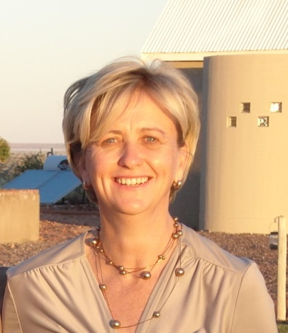  Education  01 / 2016 – 12 / 2017  01 / 1986 – 12 / 1989  01 / 1973 – 12 / 1985  Professional Experience  09 / 2016 – on-going  03 / 2014 – on-going  05 / 1995 – 02 / 2014  04 / 1991 – 04 / 1995  01 / 1988 – 03 / 1991  Experience: | Beatrix Marggraff  - S&B Übersetzungen, Schwabstr. 120, 70193, Stuttgart, Germany  - Email: anfrage@sundb-uebersetzungen.de  University of Namibia / Advanced Diploma in Translations (Cum Laude)  - Language Studies  - Culture and Translations  - German  - English  - Translation Studies  - Interpretation  Technicon Pretoria, Republic of South Africa / National Diploma in Microbiology  - Biology  - Microbiology  - Industrial and Food technology  - Statistics  - Virology  - Analytical Chemistry  - Biochemistry  Practical Education: Central Veterinary Laboratory Windhoek  Deutsche Schule Windhoek (now Delta School Windhoek) / Senior Secondary Certificate – Matriculation Grade 12  S&B Übersetzungen  - Co-owner of translation company  Deutsche Höhere Privatschule Windhoek, Namibia  - School secretariat: Translations  - correspondence  - translations English-German and vice versa of all school documentation  - correspondence for a bi-lingual multicultural school (1200 learners)  - SDL Trados translation program  African Extravaganza, Windhoek, Namibia  - Reservations manager at Namibian tourism company  - correspondence  - invoicing and reservations for Namib Naukluft Lodge  - customer consultation  - training of junior colleagues  - office supervision during owner’s absence  Self-employed, Neudamm Agricultural College General Dealer  - Co – owner of small general dealer enterprise  - procurement  - bookkeeping  - sales  - invoicing  Central Veterinary Laboratory  - 1988 – apprentice until completion of studies (practical)  - 1989 – 1991: Assistant Veterinary technician in Serology and Biochemistry  - Serology: Serological and Biochemical analysis  - Data processing for entire laboratory including several computer courses  - German, English, Afrikaans excellent (speak + write), Dutch  - French Courses at FNCC (2003 – 2006)  - Computer literate (SDL Trados for translations)

