Sreelatha Jayaprakash
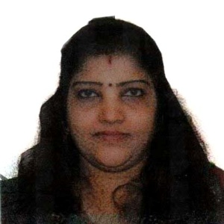

Email:
sreesishil@gmail.com
Present Address:
Bhavana,
PO Nirmalagiri
Kerala
Pin-670701  - +918281664416
Personal Data:

Name: Sreelatha Jayaprakash
Husband’s Name: KC Jayaprakash
Date of Birth: 20May1973
Sex: Female
Religion & Caste : Hindu,Vaniya
Marital Status: Married
Nationality: Indian
Languages: English,
Malayalam, Hindi, Tamil
Hobbies And Interests:
Reading, Playing Chess and listening to music

caric
Academic Credentials
- MA {English Language & Literature} 1995
(CALICUT UNIVERSITY)
- MA {English Language & Literature} 1993
(CALICUT UNIVERSITY) )

- Pree-degree in Biology Science 1990
Govt. Brennen College

- S.S.L.C 1988
Anjarakandy High School

Other Qulaifications:
Junior Diploma in Cooperation.
MS Office.
Details of Experience:

2018 till Present: Freelance translator and Spoken English Trainer
July 2009- till August 2018 as Online Advisor for www.englishtown.com in Photon Interactive Pvt Ltd.
Teaching communication and writing skills for foreign students of English including business management English and Presentation skills.
June 1999 to 2009- Administrative Assistant in S&N Insnet Educational Pvt Ltd
Experience in administrative jobs and giving training in communicative English.
Declaration:
I, Sreelatha Jayaprakash, hereby declare that all the details mentioned above are true to the best of my knowledge and I assure you that I will do my level best if I get an opportunity to work with you.

Sreelatha Jayaprakash

