 | Safiye Gamal Fouad  Place and Date of Birth : Riyad, KSA. 19th April 1993  Sex : Female  Address: Ahmed Orabi Agricultural Compound, North 9 Street, Obour City, Cairo, Egypt.  Marital Status : Single  Mobile : 01111243532  Email : sofy_1993_15@hotmail.com | 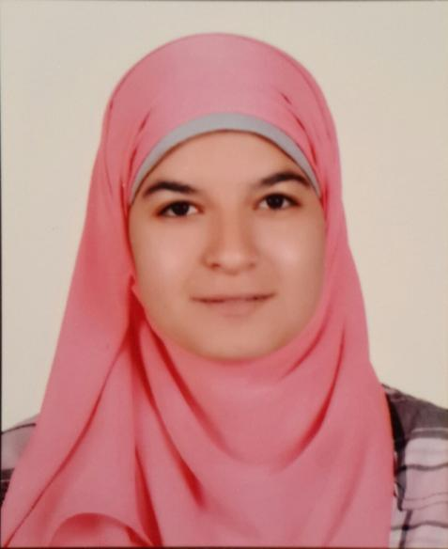

EDUCATION

2015 Graduated from Faculty of Alsun Turkish Department (Very Good )

WORKING EXPERIENCE

April 2021 – Now Freelance translator from Turkish into Arabic At ollang Lab
2015-Now Freelance translator from Turkish into Arabic at Almesryoon newspaper
2015-2016 Freelance translator from Turkish into Arabic at Zamanarabic
2013 Trainee in Wikipedia Educational Program (3rd Version )

COURSES AND CERTIFICATIONS

2015 English course at Harlem English College
2014 B2 Level certification In Turkish Language Held By Dilest Publication
Won 1st place in Egypt’s Turkish Language Olympics
2013 Turkish Conversation course at El-Raja center

2012 Turkish course at Nile Center for Turkish language and culture
Turkish Translation course at Istanbul Center
2011 Turkish course at MODLI

SKILLS

- Languages
- Arabic ( Native )
- English ( Intermediate )
- Turkish ( Intermediate )

- Microsoft Office
- Power Point

About Me:
I value teamwork and have successfully been a leader of a team myself three times at my university. I have the ability to work under pressure and have never missed a deadline. I’m willing to work for long hours and on my weekends and holidays. I’m confident in my ability to learn and acquire news skills quickly.

