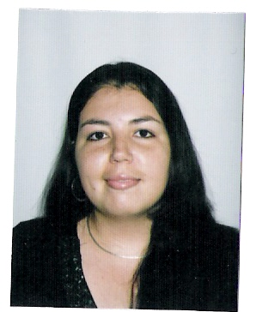
Sofía Fernández Machado
University of Costa Rica
School of Modern Languages

Personal Information:
Date of Birth: November 29 of 1984
ID number: 3-399-041
Marital Status: Single
Address: 25 mts. este de las piscinas del Polideportivo. Urbanización San Luis Gonzaga. Cartago Centro. Costa Rica
Mobile phone number: (506) 8823-1430
Email:
sofymachado22@gmail.com/sofymachado@yahoo.com/FeryMach29@gmail.com

Skype ID: soferma_cr

Objective: To obtain knowledge and experience, as part of my personal development, and a source of income.

Education:
Jesús Jiménez Zamora Elementary School. 1991-1996
Elementary School Conclusion
Sagrado Corazón de Jesús High School. 1997-2001
High School Conclusion
Bachelor in English 2002-2007
University of Costa Rica
Master in Translation English-Spanish 2008-2009
National University of Costa Rica

Special Studies:
Technological Institute of Costa Rica. Conversational English Program 1998-2000.
Sagrado Corazón de Jesús High School, Computing workshop. 2001
Technological Institute of Costa Rica. Educational workshop. Development of Material to Teach Spanish as a Second Language. 2012

Experience:
Student Hours at the Tinoco Library, University of Costa Rica. 2003
Work for an official translator (freelancer). 2006- up to now
Work for GradeResults. February, 2010- up to now
Translation of Articles in different areas: Tourism, Medical Tourism, Advertising, Finance, Food, Legal, Human Resources, Technical…
Development of content for GradeResults.
LA, Spanish, Bilingual, and ESL tutoring.
Translation of lessons and educational material for GradeResults.
Work for SpanSource. March 2012- up to now
Proofreading and Editing of Technical Documents.

References:
Tinoco Library, University of Costa Rica. Flory Gamboa Umaña, MSc.
Chicago, United States. Ana Marcela Herrera Palma, Official Translator.
Telephone: 7082052623. Email: marceher@racsa.co.cr/anamarcelaherrera@gmail.com
Santa Fe, Rosario, Argentina. Natalia Alloatti. Project Manager, SpanSource.
Telephone: +54 341 528 5247. Email: natalia.alloatti@spansource.com

