Curriculum Vitae
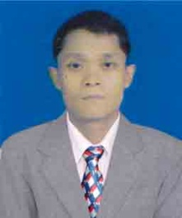
Name : Soe Min Latt

N.R.C. No : 12/ DGN (N) 027108

Nationality : Myanmar

Occupation : Volunteer English Teacher (Sky Age Free Mobile Education
Group)

Education : (1) B.A (History)
(2) Diploma of Management Account (LCCI)(UK)

Other Qualification : (1) Certification of Human Resource Management.
(2) Certification of Conflict Management (MMEC)
(3) Certification of Active Community Engagement
(4) Certification of Micro-economic Principles (on Line)
(5) Certification of English for Special Purposes(American Center)
(6) Taking a course of Sustainable Development ( on Line)

Work Experiences : Captain (Army) (1996 to 2004)
Administrative Manager ( Kaung Myat Company} (2012 to 2013)
Volunteer teacher (Sky Age Free Mobile Education Group)

Resource language : English
Target Language : Burmese
Rate : My minimum rate is Euro 0.02 to 0.05 per word
Translation fields : General/ Management / Government and Politics/ Social sicence/
: Humanities/Military
Years in Translation : Over 7- year period from 2007 to 2014
Skype ID : garmanibo24

Contact Address : No (1/A), Myinttamon Street,
Taung Thu Gone Ward, Insein, Yangon,Myanmar.
.
Contact Phone No : +95 1642858, +95 9 31870845

Contact e-mail : soeminlatt.garbo2014@gmail.com

signature

