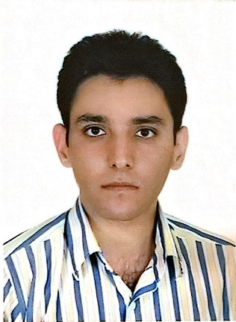
Personal Details:
Full Name: Sina Alizadeh Tabrizi
Born date: 7 March 1988
Location: Urmia, West Azerbaijan Province, Iran.
E-mail: alizadehtb@gmail.com
Skype Id: sina.alizadehtbr
Mob No. +98-937-004-4409
Personal Profile:
I am freelance translator of technical papers which are planned to be submitted to ISI/ Scopus indexed journals. Anyone who considers my CV, always has asked me why I have studied two disciplines, which are so divergent. In fact, my main objective of studying Software Engineering and English translation simultaneously during years of 2009-2011 was to fill the research gap linked to the machine translation, software localization, and quality assessment/assurance tools and try to vigilantly observe the pros and cons of the present practices, particularly in testing a localized software in terms of linguistic. To this end, I accomplished my M.A thesis with a focus on quality assurance of a localized software and machine translation.

Education and Qualifications:
2013- 2016: East Azerbaijan Science and Research Branch, Islamic Azad University, M.A
in Translation Studies, Thesis Topic: Applying Quality Assurance Models
(LISA QA model, SAE J2450 Metric and MQM) on two Localized Financial
Software by Google MT
2009-2013: Payame Noor University of Urmia, B.A in Translation.
2007-2011: Islamic Azad University of Shabestar, BSc in Software Engineering, Implemented
Project: Banking Software on the basis of Islamic Banking Approach.
1 March-1 April: Pedagogy Certification.

Programming and software development Skills: Windows application programming using C# Microsoft, Visual Studio 2012 (OOP, Linq to sql, Entity Framework, ADO.NET, etc.), Sql Server 2012, Crystal report, C++, UML (Rational Rose),
Translation Domains: Civil Engineering (Structures, Hydraulic, Soil), Software Engineering, Management (Administration and Business), Biomedical Engineering, Agricultural Engineering (ecology, vegetation, water resources management), Tourism, Medical (Orthopedic), Marketing, Localization (software and website), Banking (both Islamic and conventional banking approaches), Microbiology, Genetic Engineering, Industrial Management
Software Skills for Translation Projects: SDL Trados Studio 2015, memoQ,
Language pairs: (Persian, English), (Persian, Turkish), (English, Turkish) (Turkish, English)

Work Experience:
March 2011- September 2012: Database Analyzer and Designer at Saderat Bank
Offering computer-based Solution for other departments of
Bank.
May 2013- present:
- Freelance translator (translating research papers of Civil Engineering- for Department of Civil Engineering, Islamic Azad University, Neyshabur Branch, Neyshabur, Iran, Hakim Sabzevari University, Sabzervar, Iran). Job description: I am steeped in translating the scholarly articles from Persian to English in order for submitting to the ISI/Scopus indexed journals. Moreover, I am responsible for applying the journals format on the translated papers, tracking submitted papers and communicating with Editor-In-chief of the journals.
- Programming Course Instructor at Vocational and Technical Schools, Software Developer at Mahan System

August 2015- Present
- Negotiations with scholarly journals for publishing the selected quality papers of engineering conferences in Special Issue.

