CURRICULUM VITAE
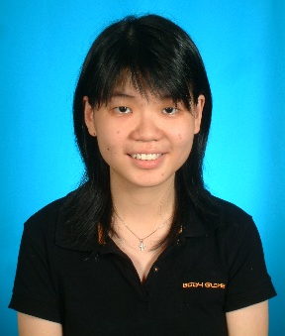
PERSONAL PARTICULARS
NAME |  |  | : THIAN SIAW YIN
NRIC NO. |  |  | : 860726-52-5640
PLACE OF BIRTH |  |  | : KUCHING, SARAWAK
NATIONALITY |  |  | : MALAYSIAN
EMAIL |  |  | : siawyin_thian@yahoo.com
PERMANENT ADDRESS |  |  | : NO. 25, LOT 1765, LAMAN BONG CHIN TERRACE, JLN ROCK,  93200 KCH, SARAWAK.
MAILING ADDRESS |  |  | : (Same as permanent address)
PHONE NUMBER |  |  | : 012-8955135
SEX |  |  | : FEMALE
RACE |  |  | : CHINESE
MARITAL STATUS |  |  | : SINGLE
LANGUAGES
SPOKEN AND WRITTEN |  |  | 1. ENGLISH | 2. BAHASA MALAYSIA | 3. CHINESE
EDUCATION
Sep 2013 – Currently |  |  | Universiti Tenaga Nasional |  | Kajang, Selangor
- Pursuing PhD degree in Civil Engineering
2009 – 2012 |  | Universiti Tenaga Nasional |  |  | Kajang, Selangor
- Course | : Master in Civil Engineering
CGPA | : 3.33
2004 – 2009 |  | Universiti Tenaga Nasional |  |  | Kajang, Selangor
- Course | Bachelor in Civil Engineering (Hons.)
CGPA | : 3.50
1999 – 2003 |  | Sekolah Menengah Kebangsaan Green Road |  |  | Kuching, Sarawak
SPM | : Aggregate 6, Grade 1
PMR | : 8 As
EXTRA CURRICULUM ACTIVITIES
2003 – 2008 |  |  | Universiti Tenaga Nasional |  | Kajang, Selangor
- Participation of Innovation & Invention Design Competition (InDec 2007)
- Committee member of the Christmas play, organized by Uniten Christian Fellowship Association
WORKING EXPERIENCE
Industrial trainee
- Joined Jurutera Perunding Primareka Sdn. Bhd. (Puchong)
  - Design buildings
  - Drafting
- Joined HSS Engineering Sdn. Bhd. (Bandar Sri Permaisuri)
- Design highway and road signage
- Drafting
Translation jobs (freelance)
- ADR Sdn. Bhd.
  - Translate documentaries and movies
- BERJAYA HVN Sdn. Bhd.
  - Translate movies
- Sky Tech Sdn. Bhd.
  - Translate movies
Languages : English to Malay (vice versa); Chinese to Malay; Chinese to English
Preference : Drama series

