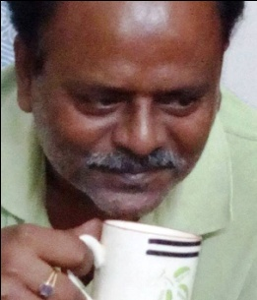

NAME | SHYAMAL KUMAR DAS
Father’s name | Late Santosh Kumar Das
Date of birth | 14.08.1964
Address | B 48/1, R.K.Upanibesh, Near Krishna Glass Factory, Kolkata - 700092
Telephone | 9883277814
e-mail | dashyamal0@gmail.com
Languages known | 1) Hindi 2) English 3) Bengali 4) Bhojpuri
Education | B.Sc, Post Graduation Diploma in Computer Application - 1988
Job experience | Computer / Internet literate with good typing speed, Worked as a freelance software programmer for Jute Mills, Sugar Mills, Banks, Market Research groups, etc. for more than 20 years  Having good knowledge of Homoeopathy.
Present occupation | Working as freelance translator (target & source languages - Hindi / Bengali & English) from home, with various agencies for last two years. Having own pc with unlimited broadband connection.
Specialization | Any. (viz. IT, General, Science, Medical etc…) I work with a team of translators belonging to various fields.
Mother language | Bengali
Native language | Hindi
Translation | English > বাংলা (Bengali)

