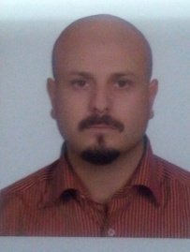
- Personal information
Name & surname: SHADI IDREES
Date of birth: Sep 16, 1985
Place of birth: SYRIA, LATTAKIA
E-mail: bisantrans@yahoo.com
Marital status: Married, no children.
Address: number.15, Plaque 53, Kohestan1 Avenue, Kohestan Street, esteghlal blvd, Tehran, Islamic republic of Iran.
Tel: 00982177074262, Mobile: 00989109113365
Notice: I have lived in Iran since 2005, I am very fluent in Arabic & Persian and I can work by the internet.
- Qualifications
- Bachelor of maritime technology, Amirkabir University of technology, Tehran, Iran, June 2013.
- Experience
- 5 years independent work experience in translation from English to Persian & Arabic. (I can translate about 750-1200 words every hour).
- 3 years of work experience in translation from English to Persian & Arabic in Sofara official translation office.
- Skills
- Computer skills, Microsoft Word, Excel, PowerPoint
- English, Arabic & Persian language skills

