Personal Info 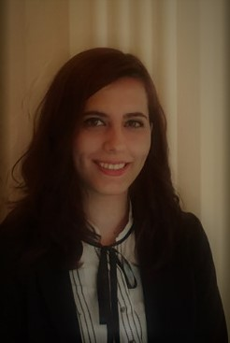

Seren Alçı

(0)534 363 52 08

serennalci@gmail.com

ssss

se

ser

Place and Date of Birth: Erzincan/ 11.08.1994
Marital Status: Single
State/Province: Turkey/İzmir

Educational Background
2012-2016: Department of Translation and Interpreting in English, Ege University, Bachelor’s Degree
2008-2012: İ.M.K.B Gürsu Anatolian High School, Bursa

Languages and Programs
English : Advanced
German: Intermediate
Italian: Beginning
Office Programs : Good

Work Experiences
2014 July- September: Coborn’s Cashwise(US)- Cashier
2015 February: Fuar İzmir/ IFWedding Fuarı- Interpreter
2014 March: Fuar İzmir/ Marble Fuarı- Interpreter
2015 April: Fuar İzmir/ Olivetech ve Ekoloji Fuarı- Interpreter
2015 September: Fuar İzmir/ Shoexpo- Interpreter
2015 October: Akare Yurtdışı Eğitim Fuarı- Seminar Interpreter
2015- Translation of Adam Mathew’s book ‘’Life About UK”
2016-2018- Ricoh Baskı Çözümleri Sales Support Assistant/Social Media Marketing Specialist
2016- ….- Freelance/Part Time/Project Based Translator in differentnetworks such as Fiverr, Armut.com, Proz.com or companies such as Turuncu Translation Office, Sentro Foreign Languages and experience of translating websites such as pestemal.com, beyyoglu.com, bayrakcimetal.com and etc.

Seminar and Programs
2011-2012: Volleyball and Scrabble Tournaments
2013-2014: Work And Travel Student Exchange Program / USA
2013- December: Effective Communication Seminar / The Ministry of Youth and Sports –Izmir
2013- Turkish Education Volunteers Foundation
2014-2015: Community Volunteers Foundation
2014- Latin Dances
2015- Folk Dances

