o
Mouhyeddine  Sara  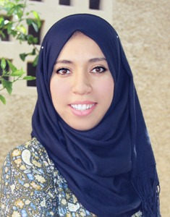  MARITAL STATUS  - 28 years  - Moroccan  - Married  CORDINATES  Phone number :212 6 66 53 93  Email : sari18set@gmail.com  Adress : unite I n° 70 daoudiate lotissement habouss , Marrakech ,Maroc  LANGUAGE  Arabic : Fluent  English : Fluent  French : Fluent  COMPUTER SKILLS  -Word /excel  -Power point  -Internet  - Translation machine  INTEREST  Travelling, reading, basket-ball, aerobic | Resume  EDUCATION  2015-2017 Master degree in Translation Technology and Specialized Translation. Cadi Ayyad University, Marrakesh, Morocco.  2014 2010-2012 TEFL certificate at the ALC Marrakech, Morocco. BA English studies : 2010 : first year of English studies 2011: Second year of English studies (DEUG) (second year university diploma). 2012: Third year English B.A studies in (linguistics). Cadi Ayyad University. Marrakech,Moroco Advanced level at the Centre de Langue et de Culture (CLC). Marrakech, Morocco  2008-2009 Bachelor degree (science major). Cadi Ayyad High school, Marrakesh, Morocco  PROFESSIONAL EXPERIENCE  2014-2018 2013-2017 2013-2014 2012-2013 2011-2013 2010-2012 EFL Teacher at the Center of Language and culture In Marrakesh, Morocco. Freelancer translator. Group Leader for international students at Rustic Pathways.USA English teacher at university Cadi Ayyad. Marrakesh. Morocco. Primary English teacher at Les Printemps school, Marrakesh, Morocco. Voluntary teacher at Ajial Litanmiya Association, Marrakesh, Morocco. Hosting American students of the CLC, Marrakech, Morocco.  2010 Member of the organizing committee of the forum (World Economic Forum on the Middle East and North Africa 2010).Marrakesh, Morocco.

