RESUME
Personal Information
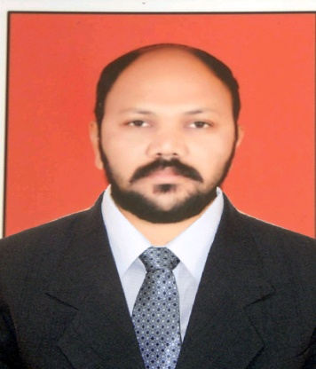
Name : Santosh Rajaram Sandanshiv
D.O.B. : 3rd February 1982
Cast : Buddhist (SC)
Nationality : Indian
Ethnicity : Maharashtrian
Profession : Mechanical Engineering Professor and Freelancer in translation
Permanent Address : Shrushti Heights, Flat Number- A101, Sri Nagar, Kiwale-412101
Cell No. : 9890298057
Email Id : santoshsandanshiv@gmail.com
Languages : Marathi, Hindi and English
Language I can translate : English to Marathi OR Marathi to English
: Hindi to Marathi OR Marathi to Hindi, English to Hindi (vice-versa)
Rate per Word : 0.70 Rupees per word and variable (Depends on Project)
Marital Status : married

Academics
Year of Passing | Institution | University /Board | Percentage
2006 | D.Y.Patil College of Engineering, Akurdi, Pune (BE Mechanical) | Pune University | 57
2009 | VIT,Biwewadi, Pune (ME design) | Pune University | 62
2011-present | VIT,Biwewadi, Pune P.hd (pursuing ) | Pune University

Experience Details:
- Freelancing in translation since 2018.

Daily Output (in words):5000
Thanks,
Santosh Sandanshiv,
Pune, Maharashtra.

