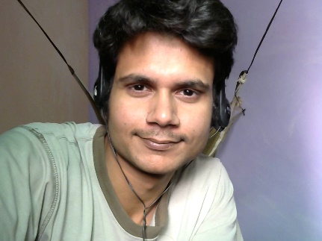
Email id :thesand002@gmail.com
Contact No. : +91-9990446483,
Skype + G-talk = “thesand002”
DOB ; 01-07-1990
Address; 157, Mangal bazaar road,
Prem Nagar, Karawal Nagar
Delhi- 110094.

I’m Sandeep. I began to work as a copy writer in 2012. I prefer to work in Hindi language even though I have also worked in English for German company namely Solveta. During the work; I specially keep an eye on style, quality and consistency for the subject. But I don’t have an excellent command on English grammar.
I don’t have any experience in voice-over job, even though, technically I am able to work as a voice-over artist in Hindi and English both languages and I have acceptable knowledge of Sound Forge Audio Studio.

EDUCATIONAL QUALIFICATION :

- COMPANY SECRETAIRIES (pursuing executive programme)

- B.COM (2008-2011) with 59.5% marks
From S.D.P.G. College, Ghaziabad
(Affiliated to CCS University Meerut U.P)

- Intermediate (U. P. Board) with 55.20% marks in 2007
From UP College Varanasi

- High School (U. P. Board) with 65.83% marks in 2005
From Saraswati Inter College Chandpur Varanasi.

Work Experience:

- Category: Copy writer
Company Name: Solveta
Company Profile: Internet advertising media company Pinneberg, Germany
http://www.solveta.com/

- Category: Copy Writer &Online Editor
Company Name: Basera magazine
Company Profile: Hindi weekly magazine, Munich, Germany

- Category: Copy Writer &Screenplay and dialog writer
Company Name: Dreamz TV.
Company Profile: Plot no:- 20/6/19 site-4 Shahibabad Industrial Area
Near Kaushambi Metro Station
Ghaziabad U.P-201010
www.dreamztv.in

- Category: Copy Writer &Screenplay and dialog writer
Company Name: PriyankaShahi creation Production Company.
Company Profile: TV film production Company, Saket, Delhi
http://youtu.be/2KIdqU_Y1ZM

Place: Delhi (SANDEEP TIWARI)

