CURRICULUM VITAE

**Contacts:**

|  |  |
| --- | --- |
| **Permanent Address :** C/O- Shyam Sharma  Vill-Danga Para  P.O.- Pandapara Kalibari  Dist. Jalpaiguri  PIN Code.735132  West Bengal, India. | **E-mail-**  [**sandysharma573@gmail.com**](mailto:sandysharma573@gmail.com)  **Phone-**  **+91 9614567370 (Mobile)** |

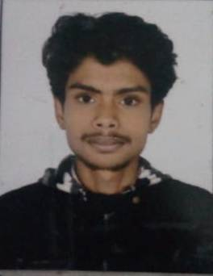

**PERSONAL DETAILS**

* **Name** :- **Sandeep Sharma**
* **Date of Birth** :- 3rd October 1995 (03/10/1995)
* **Father’s name** :- Shyam Sharma
* **Marital Status** :- Unmarried
* **Sex** :- Male
* **Religion**  :- Humanity
* **Nationality** :- Indian

**ACADEMIC QUALIFICATION**

|  |  |  |  |  |
| --- | --- | --- | --- | --- |
| **EXAMINATION** | **BOARD/UNIVERSITY** | **YEAR OF PASSING** | | **PERCENTAGE** |
| MADHYAMIK | W.B.B.S.E | 2011 | | 67.5 % |
| H.S | W.B.C.H.S.E | 2013 | | 63.2 % |
| GRADUATION | N.B.U | | 2016 | 42 % |
| Post graduation | R.B.U (distance education) | | 2019 | 55.37% |



**COMPUTER KNOWLEDGE**

* Bengali – Read , Speak , Write
* Hindi – Read , Speak,
* English – Read , Write, Speak

Basic Course in Computer Application.

**DECLARATION**

I, **Sandeep Sharma** declare that all the information given above is true to the best of my knowledge and belief, and I have substantial proof to support them.

Date:

Place: Jalpaiguri

***Sandeep Sharma***

………………………………………………..

Signature