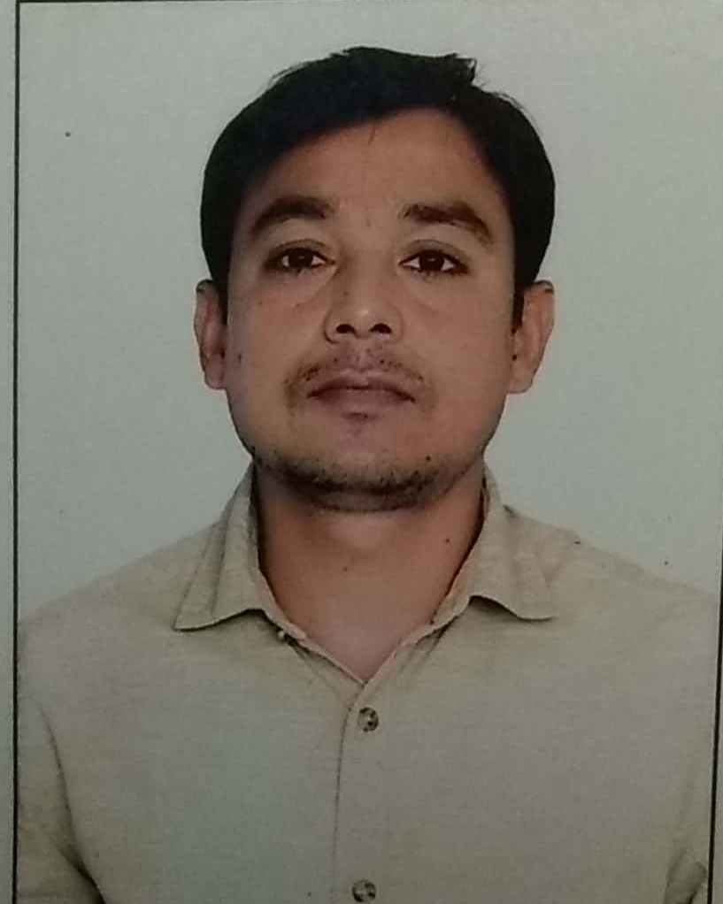

BIODATA

Sandeep kumar

Department of Hindi
University of Hyderabad
Gachibowli, Hyderabad
Telangana, India- 500046
Mobile: +8074425417, +9369485212
Email id: diwakaruoh@gmail.com

Academic Qualifications

Examination | Board/ University | Year of Passing |  | Class/  Division
Ph.D. (Hindi) | University of Hyderabad | Pursuing |  | -
M.Phil | University of Hyderabad | 2015 |  | 1nd
B ed | Csjm university Kanpur | 2011 |  | 1nd
M.A. (Hindi) | University of Allahabad | 2009 |  | 2nd
B.A.  (Hindi) | university of Allahabad | 2007 |  | 2nd
Class 12th | Up board | 2003 |  | 3nd
Class 10th | Up board | 2001 |  | 2nd

AWARDS AND FELLOWSHIPS

Qualified – UGC NET- (Hindi) in 201

Juniar research Fellowship (2014- 2019)

Up slet-2012 conducted by dr. ram mnohar lohia awadh university faizabad

Up tet-2011, primary and upper- uttar Pradesh

Ph.D Thesis
Hindi dalit kavita ka alochna paksh

M.Phil. DisSERTATION
Malkhan singh ki kavita mein dalit chetna

research paper pulication

- Malkhan singh se sandeep kumar se baatcheet, dalit asmita, October-december : 2016
- Hasiye ka samaj aur hindee dalit kavita, shasiye ka samaj hindi-marathi sahity, dr. sateesh yadav, dr. ranjeet jadhaw, aroona prakshan, 2017 : 205
- Hindi dalit kavita ka swaroop, apni maati, pri-1 to 7 Feb-2018
- Hindi dalit kavita ke maan prtimaan, samyak bharat, march-april, 2018 : 63-66
- Hindi dalit kavita ke abhyuday ki prishtbhoomi, setu pitsverg amerika, 1 to 7 : sep 2018
- Hindi dalit kavita ke abhyuday ki prishtbhoomi, sahity setu Hyderabad, 102 to 107, oct-sep : 2018
- Rajni tilak ke kavita rajni tilak, hasie ka samaj, 60 to 65, may-agust : 2018

WORKSHOPS AND seminars

- Presented a paper on ‘hans aur dalit vimarsh’ in an national seminar on “banaras hindu university’ 20-21october 2016
- Presented a paper on‘kavita men yatharthvaad’ trilochan ki kavita’in an national seminor’ 23october 2016
- Participated One week workshop, held by, centre for dalit adivadi studies and translation department university of Hyderabad 2nd to 8nd march 2016
- Presented a paper on ‘Venu-gopal ki kavya-chetna’ in a national seminar on “Venu-gopal ki kavya-chetna” held by Department of Hindi, University of Hyderabad on November 12, 2016.
- Presented a paper on ‘adiwasee sangharsh vinod kumar shukl ke upasyason mein’ in a national seminar on “adiwasee sahity vimarsh: samay aur sandarsbh ” held by Department of Hindi, dr. hari singh gaur vaishvidhyalay, sagar (m.p.) 02-03 march 2017.
- Presented a paper on “hasie ka samaj aur hindi dalit kavita, in a national seminar held by latoor jila hindi prishad, latoor , 12 November 2017
- Presented a paper on “hindi dalit kavita ke man aur pratimaan” in the two day national seminor on ‘hasiye ka samaj aur sahity mein asmita ke ubharte naye ayaam held on 22-23 feb 2018
- Presented a paper on ‘pighle chehre’ mein yathrthvadi chetna, in the national seminor-13-08-2018
- Presented a paper on “ekssavi sadi ka hindi sahity ewam vimarsh ke vividh ayaam, in the two day national seminor held on angreji ewam videshi bhasha vishv vidyalay Hyderabad-10-11 october 2018
- Participated One week workshop “mukhydhara aur hasiye ke samaj : sinddhant, karm aur pravidhi held between 5 and13 march 2018 at csds, new delhi
- Participated two day national seminor “vaigyanik takniki shbadavalee ayog, venue-hyderabad university 5-6 april 2018

PERSONAL INFORMATION

Father’s Name : sadri Prasad

Date of Birth : 14 sep 1987
Languages Proficiency : Hindi, English
Marital Status : Unmarried
Sex : male

I hereby declare that all the information furnished above is correct to the best of my knowledge.

sandeep kumar

