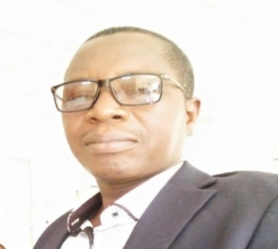
CURRICULUM VITAE
Salifou DABO
Maried, 47 years old
Tel: +226 70 46 26 70/+226 78 15 30 88
Email: salifou_dabo@hotmail.com
Ouagadougou- Burkina Faso

PROFILE
Certified senior translator with over 15 years of professional experience including 12 years in a Non-
Governmental Organization. Experienced and detail-oriented in translation and proofreading (French English-French) with a proven ability to perform quick and accurate tasks with a fast-paced deadline. Skilled at multitasking and recognized for dedication and work ethic.
EDUCATION:

- MBA in progress
- Master of Arts in English Applied linguistics( 1997)-University of Ouagadougou
- Bachelor of Arts in English( 1996)-University of Ouagadougou
- DEUG 2 in English(1995)-University of Ouagadougou
PROFESSIONAL SKILLS:

- Translation (French-English-French/local languages Moore, Dioula )
- Editing and proofreading
- Transcription/subtitling (audio-video files)
- Interpretation: simultaneous, consecutive and escort
WORK EXPERIENCE:

- 2014 up to now Managing Director at Vision 2000 English Language Center Burkina Faso
- 2009-2013 Sponsorship Administrator At CCFC ( Christian Children’s Fund of Canada)
- 2003-2009 Full time translator at CCFC
- 1999-2003 Part time translator for CCFC
FIELDS OF EXPERTISE:

Legal, Accounting, Finance, Banking, Business, Technical, Medical, ecology, environment, agriculture, websites.
LANGUAGES:

French, English, Dioula and Moore (local languages)

SOFTWARE:

MS Word, Excel, Publisher, PowerPoint, Wordfast, PDF professional, AutoCAD, Memo Q, SDL TRADOS.
SOME REFERENCES:

CCFC (Christian Children’s Fund of Canada) NGO Burkina Faso BP:
01 BP 5159 Ouagadougou 01 Burkina Faso Tel: (00226) 72 30 03 55 E-mail: info-bf@ccfcanada.ca;

ONECCA BF (National Institute of Public Accountants and Certified Accountants – Burkina Faso)
Avenue Léo Frobénius 01 BP 44 Ouagadougou 01 Tél : +226 25 31 47 50 E-mail : info@oneccabf.org; s.ouedraogo@cacsbf.com;
AIEA (International Atomic Energy Agency)
Vienna International Centre, PO Box 100, 1400 Vienna, Austria Phone: (+43 1) 2600 • Fax: (+43 1) 26007 Email: Official.Mail@iaea.org • Internet: http://www.iaea.org

PLAN INTERNATIONAL /Burkina Faso International Solidarity Organization Zone d’Activités Diverses (ZAD) 01 PO BOX : 1180 Ouagadougou 01 Tel : (226) 25 37 87 33

Living Goods USA
220 Halleck St 200B
San Francisco, CA 94129-1727 USA jloiseau@livinggoods.org
AFRICTIVISTS (African League of Bloggers and Cyber-Activists for Democracy)
www.africtivistes.org info@africtivistes.org Rue 45x34 Medina Dakar-Senegal
Tel: +221 77 550 04 69 | +221 77 418 36 62;
* I certify on the honor that the information above mentioned reflect my qualifications and my experience.

