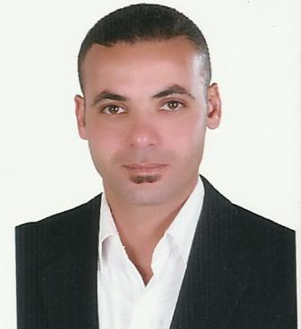
CURRICULUM VITAE

PERSONAL DATA
Name Rany Mostafa Abdel Rahman Ahmed
Sex Male
Nationality Egyptian
Date of birth 01 / 06 / 1974
Marital status Married
Military service Exempted
Contact numbers (002) 0100 3332038
(002) 02 35693545
Mailing address 5, mahgoub Thabet Street off Shahin sq.
Agouza, Giza

E.mail address ranymostapha@yahoo.co.uk
www.tourguideegypt.com

EDUCATION & QUALIFICATIONS
Bachelor degree in Tourism and hotels,
Touristic guidance dept, El Minya
University 1998

FORMER EXPERIENCES
      - Receptionist in Cairo Sheraton hotel
From 01/07/1995 To 01/ 02/1999
      - Resident Nile cruise tour guide &
director onboard of M/S Movenpick
Radamis I, M/S Movenpick Radamis II
and M/S Jasmin From 15/03/1999 to
14/02/2004
      - Guest Relation assistant manager at
Cairo Sheraton hotel from 01/04/2004
to 25/06/2005

CURRENT JOB
Self employed through www.tourguideegypt.com
Working as a tour guide and director. I do
tailor-made itineraries for travelers to Egypt &
personally conduct the sightseeing throughout
Egypt

PERSONAL SKILLS
        - Self motivated
        - Able to work with a team
        - Perform work accurately under pressure
        - Good communication with people
        - Fast learner

FURTHER SKILLS
        - Excellent knowledge of Arabic and English languages
        - IELTS 11/06/2009 – The British Council Cairo
Overall Band Score 7.0/9
Listening 7.0/9 Reading 6.0/9
Writing 6.5/9 Speaking 7.0/9
        - Good knowledge of French language
        - Very good knowledge of computer & internet application
        - Microsot office 2007 certificate 2003 “Core & Advanced”

OBJECTIVES
Seeking a challenging post in an international company
where I can utilize & develop my personal and
educational skills

ONLINE TESTMONIAL
http://www.tripadvisor.com/ShowTopic-g294201-i9404- k679521-Private_Guide_Recommendation-Cairo.html
http://www.tripadvisor.com/ShowTopic-g294201-i9404-k843232-Egypt_is_a_great_country-Cairo.html
http://www.tripadvisor.com/ShowTopic-g294201-i9404-k2202663-Tour_Guide_Recommendation_Rani_Mostapha-Cairo.html
http://www.tripadvisor.com/ShowTopic-g294201-i9404-k898833-Tour_guide_recommendation-Cairo.html
http://www.tripadvisor.com/ShowTopic-g294201-i9404-k1564672-Private_Tour_Recommendation-Cairo.html
http://www.frommers.com/community/forum.cfm/?plckForumPage=ForumDiscussion&plckDiscussionId=Cat%3aMiddle+East+and+AfricaForum%3a0EE6B358Discussion%3ab6735f22-bdbe-4fa5-ab70-faa07d5ec233#ixzz0kbzUZ1Lc

