RAJEEV MOKASHE
TRANSLATOR
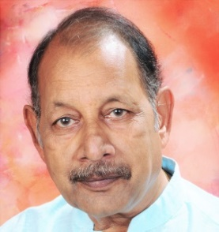
Government Electricity Board
Job Title – Stenographer (English) 1978-2015
: rajeev15mokashe@mail.com
Address:- G-2 Gajanan Prasad Apartments, Plot No. 16, Renghe Layout,
Trimurti Nagar, Nagpur – 440022 (M.S.)
: 07028299133
About me:
- Retired English
Stenographer with
Attending to the works as assigned by Director.
• Making personal correspondence in GAD/Vigilance/Enforcement/Police Stations/Security matters in English – Hindi – Marathi & preparing Office Note & proposal as assigned by Director.
• Translation of documents.
• Maintaining records of ACRs.
• Transcription work.
• Processing cases of cash rewards to informants in theft of energy cases.

37 years of
Government
Service in
Maharashtra
(India).

- Native Language
– Marathi
- Rates :
Translation:
0.07 USD per SW
Transcription:
SKILLS :
Translation/Subtitling – English <> Marathi
English <> Hindi

1.82 USD/Minute.
Proofreading:
0.03 USD/SW
Domain: Art, Entertainment, Culture, Sports, Politics, General.

Expertise : I have done English-Hindi-Marathi amateur Theater for more than 30 years. As such I have good command and excellence over English – Hindi – Marathi which helps me to translate fluently in all the three languages.

More professional details:
• Have worked on transcriptions for 3 years, including general transcriptions like seminars, interviews and legal court hearings.
• Done subtitling for 3 movies for Indian Company recently.

RAJEEV MOKASHE

