RESUME 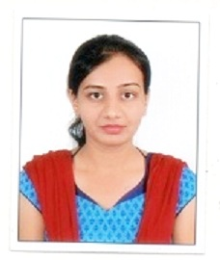
NAME : PRIYA GUPTA
DATE OF BIRTH : 12-OCT-1988
EDUCATIONAL
QUALIFICATIONS : B.Sc. (BIOTECHNOLOGY)
: M.A. (English Literature) : B.Li.Sc (Library Science)
: PG Diploma in Translation
: Certificate in Entrepreneurship
EXPERIENCE : 1 year teaching experience
CAREER OBJECTIVE : TO PURSUE A HIGHLY CHALLENGING AND CREATIVE CAREER, WHERE I CAN APPLY ANY EXISTING KNOWLEDGE AND CREATIVITY, ACQUIRE NEW SKILLS AND CONTRIBUTE EFFECTIVELY TO THE ORGANISATION.
ABOUT MYSELF :SMART WORKING AND PERSERVERING
WORK EFFECTIVELY IN A TEAM
HARD WORKING AND GOOD COMMUNICATION
SKILLS
CONTACT NO. : 9098276585
EMAIL ID : priyagupta556@gmail.com
ADDRESS : 1085 OPP SIMPLEX COMPANY NAGPUR ROAD
MADAN MAHAL JABALPUR 482002

