RESUME
Personal Information
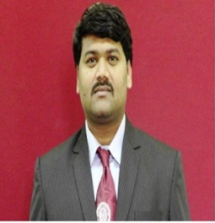
Name : Prakash Vijay Sontakke
D.O.B. : 30th September 1984
Cast : Hindu-Mahar (SC)
Nationality : Indian
Ethnicity : Maharashtrian
Profession: Professor (Electronics and Telecommunication Engineering) and Freelancer in translation
Permanent Address : Flat No. 211, Bhalchandarpuram Society, Shinde Vasti, Ravet, Pune
Cell No. : 8983314995
Email Id : ps.freelancer1984@gmail.com / prakashsontakke2020@gmail.com
Languages : Marathi, Hindi and English
Language I can translate : English to Marathi OR Marathi to English
: Hindi to Marathi OR Marathi to Hindi, English to Hindi (vice-versa)
Rate per Word : 0.70 Rupees per word and variable (Depends on Project)
Marital Status : Married
Academics
Year of Passing | Institution | University /Board | Percentage
2005 | Shree Tuljabhavani College of Engineering Tuljapur (E&TC Engineering) | Dr. BAMU Aurangabad | 74.66 %
2013 | College of Engineering Pune (M.Tech) | Savitribai Phule Pune University Pune | 68 %
2018-present | Ph.D. (pursuing ) | Savitribai Phule Pune University Pune

Experience Details:
- Freelancing in translation since 2015.
- Worked for following organizations:
- Infinity Technology
- AnshIntertrade Pvt. LTD
- Global Enterprise
- eSenceDesk

Daily Output (in words): 5000

Thanks,
Prakash V. Sontakke
Pune, Maharashtra.

