Pradeep Kumar Balhara 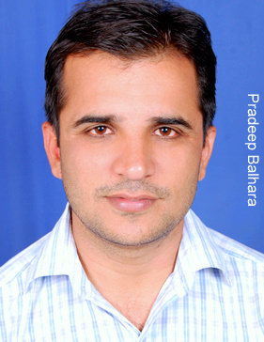 418/12, Jagdish Colony,
Hansi, Distt. Hisar, Pin:- 125033 Haryana
Phone: - 09416796293
E-mail: - pradeepbalhara75@yahoo.co.in

Career Objective
To become an effective and productive professional by continuous and quick learning for the organizational and personal growth.

Work Experience
Name & Address of Organization : The Homepages (English Daily)
Designation : Translator
Duration : Feb, 1999 to Sep. 2003
Location : Hisar(Haryana)
From the last six years I’ve been doing the translation work successfully, being attached with many translation agencies. English-Hindi as well as Hindi-English, many projects at overseas and local level are completed successfully with quality work and in the given time.
I also have been attached with the prestigious group JBD Deepak Books as a translator for a couple of years successfully.

Academic Qualification
- M.A (English) from Kurukshetra University, Kurukshetra
- B.A. from Kurukshetra University, Kurukshetra
- Pursuing Translation Diploma from IGNOU.

Professional Qualification
- Advance Certificate in PC Application from NIIT.
- SAP(ZStore, MI-20, MB-51, MB-52, MB5B etc… & P35)
- Retalix.
Software / Languages
- Windows 95,98,2000, XP,
- MS Office 2000, MS Access

Hobbies:

Playing & Watching Football on TV, Reading Magazines

Extra Curricular Activities
- State Level Football Player
- Participated in North Zone Intra-University Football Championship.
Personal Information

Name : Pradeep Kumar Balhara
Father’s Name : Sh. Kali Ram Balhara
Marital Status : Married
Language known : English & Hindi
Dialects : Haryanavi, Punjabi, Hindi
Sex : Male
Permanent Address : 418/12, Jagdish Nagar, Hansi, Hisar (HR.)-125033
References
Available on Request

( Pradeep Kumar Balhara )

