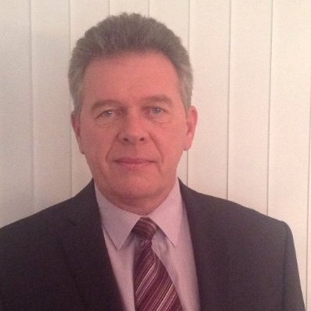
PHILIPPE CORNEZ
Groenendijkstraat 10-203
B8450 BREDENE
Tel. :+3259321917 Mobile: +32499719636
Mail: philippe.cornez@telenet.be
http://www.linkedin.com/in/cornezphilippe

30 years of experience in various executive, management en top management functions.
STRENGTHS AND ABILITIES
Decision making, critical thinking, organizing and planning.
Operational management.
Strategy development & implementation.
Excellent organizational and management skills.
Project Management & Completion.
Quality insurance implementation.
Training and education planning.
Public relations & crisis management.
Strong verbal and personal communication skills.
Superior client service mentality, outstanding presence, high flexibility.
Good understanding of media, PR, ensuring a professional and effective event management.
Very good experience in organizing and promoting corporate events including VIP packages.
Very good expertise in VIP and protocol issues in national and international environments.
Speech writer and conference speaker in several languages.
PROFESSIONAL CARRIER
- Defence & Security Country Manager (sales & expertise) with Anderson Consulting (present)
Defence & security consultant. Expert in government, defence, and security Industries, specialist in contracting, government procurement policies and practices.

- Independent Consultant, owner of NEPTUNE CONSULT. (present)

Advice & Evaluations framework of maritime safety

Project Management

Audit and expertise

Advice and expertise in:

VIPs guidance and protocol rules.

Organization of events, including sponsorship and networking.

Relationship with the media.

Education and training.

Achievements:
Independent consultant for major multinational defence contractor.

Consulting under contract with the Butler Hill Group reviewing and rating web content.
International Conference chairmanship and keynote speaker with IQPC and Clarion.
Defense and security consultant for Anderson Consulting.
Translation and proofreading for Textcase
- Director NATO Naval Mine Warfare Center of Excellence (Belgian-Netherland Naval Minewarfare School)
2009 –2012

Leading the Centre in accordance with the instructions and guidelines of the Board.

Ensure the training and courses at the school and the required educational development. Providing advice to NATO and EU.

General care, running of the school in all management areas. Including protocol, ceremonial duties and international conference organization.
Speaker at UDT Asia 2011, Oceanology 2012 –Maritime surveillance and security conference Abu Dhabi 2012 - and numerous other events
- Public relation director and Communications manager
Belgian Navy
2004 – 2009
Responsible for the coordination and implementation of the entire communication policy of the Navy
Official spokesman for the Navy with extended interview and live TV broadcasting experience
Personal advisor to the Minister of Defence
Major events (>50.000) organizer and coordinator
Responsible editor for several military/maritime publications
- Director Naval base
Belgian Navy
2001 – 2004
Logistic, material, personnel management of the Naval Base of Zeebrugge (1500 employees).
ISPS port safety implementation. Member of the Federal expert study group on ISPS.
Navy days organization (80.000 visitors)
- Principal assistant of the chief of staff of the Navy
Belgian Navy
1999 – 2001

Responsible for managing calendar, tasks and contacts - preparation of VIP visits – information analysis, secretary of the Navy Board, responsible for human resources, budgets, private secretary. Point of contact for the media.
- Head of general education Belgian Netherland Operation school
BelgianNavy
1997 – 1999
Mentor and coordinator for the operational education and training of the officers of the Belgian and Netherland Navy.
Head of the general education department.
Study and implementation of new course structure.
- Commanding Officer Belgian Navy Ship Crocus
Belgian Navy
1995 – 1996
General management of a 45 crew ship including human, material and financial resources
Participation in NATO permanent task group.
In charge of the rescue operation “Spouwer”.
- Various executive jobs
1982 – 1995
EDUCATION

Belgian Defense Communication department
Media training, Communication and Media Studies
2004
Royal Defense Institute 1994-1995
Candidate Senior Officer Course (CSOC) (leadership, human and material resources, financial management)
Operational school 1986 – 1987
Principal Warfare officer (Anti Submarine Warfare)

Royal Military Academy 1977 – 1982
Master in Maritime and Social sciences
LANGAGE SKILLS
Dutch : Mother language - Excellent
French : First Language - Excellent
English : Very good
OTHER SKILLS
Good skills in MS Office Package , SharePoint management tool.
Good knowledge of quality management system (ISO)
PERSONNAL INFORMATION
Born in Belgium 12 Feb 1957 - Married with 2 grown children’s
Available for international jobs

