CURRICULUM VITAE
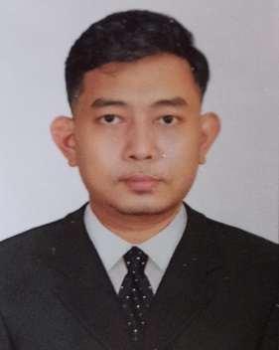
PERSONAL INFORMATION
NAME : PAING PHYOE HEIN
AGE : 32
NATIONALITY : MYANMAR
MATRIAL STATUS : MARRIED
ADRESS : C -401, MUDITAR HOUSING (1), THAMINE
TOWNSHIP, YANGON, MYANMAR.
Tel : +959421118157, +959793485426
Email : paing2395@gmail.com
QUALIFICATION
DEGREE : B.E (Marine Engineering)
LICENSE : MARINE ENGINEER OFFICER CLASS III
( ISSUED BY D.M.A, YANGON, MYANMAR )
OTHER : Studied 4 skills of English language at following schools.
- Myanmar Maritime University,
- U Wynn Naing (Hledan) Speaking class.
WORK EXPERIENCE
- Sponsor, teacher at U Wynn Naing (Hledan) Speaking Class.
- Subtitle translator for movie series
- Freelance 4 skills English teacher.
- 3rd Engineer at Hyundai Merchant Marine Co.,Ltd.
- 2nd Engineer at Hyundai Ocean Services Co.,Ltd.

