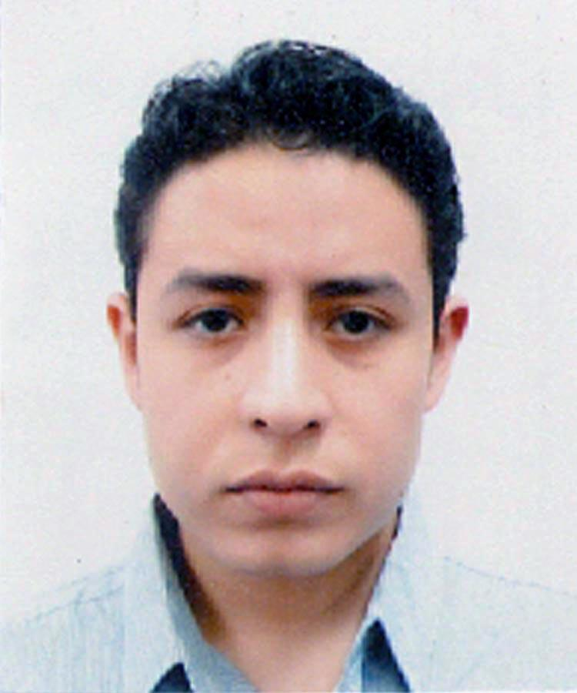
Oscar Alberto Aguado-Servín
Professional license: 09649784
(Mexican National Registry of Professionals http://www.cedulaprofesional.sep.gob.mx/cedula/indexAvanzada.action)
Date of birth: 02.06.1991
Phone number: 01521 55 60 79 53 41
E-mail: oscar.isit@live.ca

ACADEMIC BACKGROUND
Certification in Translation of Specialized Texts (DTTE)
Institution: National Autonomous University of Mexico (UNAM)
January 2015- December 2015

Bachelor’s degree in English Teaching
Institution: National Autonomous University of Mexico (UNAM)
2009-2013

WORK EXPERIENCE
- National Autonomous University of Mexico’s language school (CELE)
Term: November 2012- Current
Position: English teacher
- Freelance Translator
Term: November 2012-Current

Tekamolo (Translation agency)
Term: September 2015- current
Position: Translator
- Cornerstone Language Community (translation agency)
Term: January 2015- September 2015
Position: Translator

National Polytechnical Institute (IPN), CECyT 10-.

Position: English teacher

Term: September 2012 – November 2012
AWARDS

Silver Medal “Gustavo Baz Prada” awarded by the National Autonomous University of Mexico in 2013 for research on first language acquisition and bilingualism.

SCIENTIFIC PRODUCTION

Aguado-Servín, O.A., Arias-Trejo, N. (submitted). How informative are noun inflections during word learning? Morphological bootstrapping in Spanish-speaking children. Language Acquisition.

Arias-Trejo, N., Abreu-Mendoza, R.A., Aguado-Servín, O.A. (2014). Spanish-speaking children production of number morphology. First Language. 34(4), 372-384. doi: 10.1177/0142723714544411.

